Deployment Performance Review of the 2020 North Pacific Observer Program

P. Ganz1, C. Faunce2, *, G. Mayhew3,S. Barbeaux4, J. Gasper1, S. Lowe4, and R. Webster5

1Sustainable Fisheries Division

Alaska Regional Office

National Marine Fisheries Service

National Oceanic and Atmospheric Administration

709 West 9th Street

Juneau, AK, 99801

2Fisheries Monitoring and Analysis Division

Alaska Fisheries Science Center

National Marine Fisheries Service

National Oceanic and Atmospheric Administration

7600 Sand Point Way NE

Seattle, WA 98115

3Pacific States Marine Fisheries Commission

Alaska Fisheries Science Center

National Marine Fisheries Service

National Oceanic and Atmospheric Administration

7600 Sand Point Way NE

Seattle, WA 98115

4Resource Ecology and Fisheries

Management Division

Alaska Fisheries Science Center

National Marine Fisheries Service

National Oceanic and Atmospheric Administration

7600 Sand Point Way NE

Seattle, WA 98115

5International Pacific Halibut Commission

2320 West Commodore Way, Suite 300

Seattle, WA 98199

* Corresponding author

E-mail address: craig.faunce@noaa.gov

# Abstract

This report contains analyses and findings that, taken together, are meant to evaluate how closely the North Pacific Observer Program (Observer Program) was able to monitor commercial fisheries in Alaska relative to the monitoring goals set in the 2020 Annual Deployment Plan (ADP). This report is authored by the Fishery Monitoring Science Committee (FMSC), which is established each year by the Alaska Fisheries Science Center’s (AFSC) Fishery Monitoring and Analysis Division (FMA) for the purpose of reviewing scientific elements of the Observer Program. Specifically, this report and the ADP focus predominantly on the partial coverage portion of the Observer Program, which contains vessels that have less than 100% of their trips monitored. Responses to comments by the North Pacific Fishery Management Council (Council) from the 2019 version of this report, and recommendations to improve data quality and guide the 2022 ADP are also included.

In 2020, there were 16 strata to evaluate: two full coverage strata, nine partial coverage observer strata defined by gear designation and time period, three partial coverage electronic monitoring (EM) strata defined by gear designation, one zero coverage EM research stratum, and one zero coverage stratum. Of those 16 strata, two were under an exempted fishing permit (EFP) to test the ability of EM equipment to monitor fishing on trawl vessels. One EFP stratum was in full coverage, and one was in partial coverage. Outside of the EFP, observers were deployed to 2,856 full coverage trips on 143 vessels and 319 partial coverage trips on 176 unique vessel and stratum combinations (vessels can fish in more than one stratum). In total, 900 trips were monitored with EM across all gear types, with 647 of those trips occurring in the trawl EM EFP and 253 of those trips occurring in the regulated fixed gear EM program. A total of 320 vessels fished 1,403 trips under zero coverage, accounting for 25% of all trips that occurred within the partial coverage category. Research EM systems were deployed onto two vessels that fished for 22 trips.

Fisheries monitoring in 2020 was substantially impacted by the COVID-19 pandemic, although the impacts were not uniform across monitoring tools. The FMA successfully deployed observers to 99.7% of trips in the full coverage observed stratum, and only one of the eight trips not covered was related to COVID-19 response. Similarly, EM strata were largely unaffected by the pandemic, meeting expected monitoring rates in all strata. The strata most impacted by the pandemic were the partial coverage strata that are monitored by observers. For these strata: three distinct time periods were created by the response to COVID-19: one in which deployment was largely unaffected (January 1 through March 25), one in which observer coverage waivers were issued broadly (March 26 through June 30), and one in which observer deployment resumed out of a limited number of ports (July 1 through December 31). Realized coverage rates met expectations for all partial coverage observed strata in the first time period. Realized coverage rates were lowest during the second time period, although there was no statistical expectation of coverage due to the waivers being issued. In the third time period, realized coverage rates met expectations for the trawl stratum, but were lower than expected for the hook-and-line and pot strata.

In order to improve the 2022 ADP, the FMSC recommends that all trips logged in the Observer Declare and Deploy System (ODDS) be closed using an existing pull down menu that lists landing report numbers associated with the vessel landing the trip. The FMSC has recommended for multiple years that the ODDS system be linked to the electronic reporting system that records landings (eLandings) so that intended deployment can be reliably compared to realized deployment. The recommendation that trips be closed with landing report numbers describes how that link can be made with minimal impact to participants. The FMSC also recommends that the sampling design for the 2022 ADP use trip as the primary sampling unit and that the design not be constrained by port of departure or landing unless such a constraint is necessary for health and safety reasons. In 2020, statistical tests of spatial bias were not able to be performed, due to the use of waivers and port-based deployment. Deploying observers with trip selection from all ports will improve the FMSC’s ability to determine whether the data collected by observers was spatially representative of all fishing.

**Contents**

Abstract iii

Introduction 6

Background of the North Pacific Groundfish and Halibut Observer Program 6

The Annual Deployment Plan and Review 8

Fishery Monitoring Science Committee 8

The Sampling Design of the Observer Program 9

The 2020 Annual Deployment Plan 11

Performance Review Objectives 13

Observer Deployment Performance Metrics 15

Changes to This Report from Last Year 17

Evaluation of Deployment in 2020 18

Evaluating Effort Predictions 19

Performance of the Observer Declare and Deploy System in Trip-Selection 20

Evaluation of Deployment Rates 21

At-sea Deployments 22

Timeliness of at-sea data 23

Coverage Rates for Dockside Monitoring 23

Sample Quality 24

Temporal Patterns in Trip-Selection 24

Spatial Patterns in Trip-Selection 25

Trip Metrics 25

Were monitored trips similar to unmonitored trips? 27

Gear, tender, and observed status combinations 27

Adequacy of the Sample Size 28

Response to Council and SSC Comments 28

FMSC Recommendations to Improve Data Quality 29

Recommendations from the 2019 Annual Deployment Review 29

Recommendations to Improve Data Quality and Guide the 2022 ADP 30

Citations 31

Tables 33

Figures 39

# Introduction

## Background of the North Pacific Groundfish and Halibut Observer Program

Fisheries observers and electronic monitoring (EM) systems collect independent information that is used to determine the effects of fishing on natural resources. The National Marine Fisheries Service (NMFS) uses its observer program in Alaska to enable the use of tools such as catch quotas to manage against the over- or under-harvest of fishes. Observers and EM are two verifiable methods for collecting fishery discard information used to estimate total catch. Observers are able to record seabird and marine mammal interactions with fisheries as well. Observers also collect biological information such as length, sex, weight, ageing structures (e.g., otoliths, spines, scales, and vertebrae), and stomachs to support ecosystem studies and stock assessments.

The observer program in the North Pacific has a long history. Observers were first deployed onto fishing vessels in the Bering Sea in 1973 and into the remainder of the North Pacific in 1975 (Nelson et al. 1981, Wall et al. 1981). Fisheries in the North Pacific were initially prosecuted exclusively by foreign and later by “joint venture” operations where a developing domestic fleet of catcher vessels delivered to foreign-owned processing vessels. During the foreign and joint venture operations, foreign vessels carried fisheries observers at their expense, while domestic vessels were exempted from this observer coverage. As foreign vessels’ rights to fish in the U.S. Exclusive Economic Zone (EEZ) were reduced over time and the domestic fishery grew, it became obvious to managers that observer coverage would be necessary for the emerging domestic fleet. At the onset of fully domestic fishery operations in 1990, the North Pacific Groundfish Observer Program was established as an interim observer program with rules governing observer coverage codified in regulations. This interim program would be extended four times over the next 20 years by the North Pacific Fishery Management Council (Council) - the last without a sunset date.

The regulations established in 1990 required vessels 60-125 feet in length (overall) and all vessels fishing pot gear to carry observers at their own cost for 30% of their fishing days in a calendar quarter. In addition, these vessels (termed the “30% fleet”) were required to carry observers on plus at least one trip in each fishery they participated in. (termed the “30% fleet”), and vVessels greater than 125 feet in length were required to carry an observer for 100% of their fishing days at their expense. Some vessels were not required to carry observers. These included vessels less than 60 feet, vessels fishing jig gear, or vessels fishing with trawl gear that deliver unsorted codends to processing vessels (termed “catcher processors” or CPs if the vessel also has catching ability and “mothership” or M if the vessel does not), and vessels that fished for Pacific halibut (*Hippoglossus stenolepis*). For shoreside processors, tThe rules governing observer coverage for shoreside processors were based on the estimated tonnage processed in a calendar month: plants that processed less than 500 metric tons (t) a month were exempted from coverage, those that processed between 500 t and 1,000 t a month were required to be observed for 30% of the calendar days, and those that processed more than 1,000 t a month were required to be observed for each day in the month.

Soon after the establishment of the domestic observer program, concerns over the ability and incentive for fishers to manipulate observer coverage in a way that might bias catch estimates and other analytic products prompted efforts by NMFS and the Council to provide a mechanism for NMFS to gain control over where and when observers were deployed (Faunce and Barbeaux 2011). From 1992 to 2008, several attempts to “restructure” the program were made. In 2010, the Council unanimously decided to move forward with the restructured observer program. In 2012, the Final Rule 77 FR 70062 was published to implement Amendment 86 to the Fishery Management Plan for Groundfish of the Bering Sea and Aleutian Islands (BSAI) Management Area and Amendment 76 to the Fishery Management Plan for Groundfish of the Gulf of Alaska (GOA). Amendments 86/76 added a funding and deployment system for observer coverage to the existing North Pacific Groundfish Observer Program and amended existing observer coverage requirements for vessels and processing plants. The “restructured” North Pacific Groundfish and Halibut Observer Program (hereafter termed “Observer Program”) began in 2013 with the randomization of deployments among trips and vessels. In 2018, the use of EM was added as an additional catch monitoring tool, with the understanding that some data elements collected by observers would not be collected using EM systems.

# The Annual Deployment Plan and Review

The restructure of the Observer Program established new annual reporting processes. Each June, the NMFS provides the Council with a comprehensive reviewevaluation of past years’ observer deployments, costs, sampling levels, and implementation issues as well as recommended changes for the coming year. This reviewevaluation is referred to as the Observer Program Annual Report. As one chapter of the Annual Report, the deployment performance review aims to identify areas where improvements are needed to 1) collect the data necessary to manage the groundfish and halibut fisheries; 2) maintain the scientific goals of unbiased data collection; and 3) accomplish the most effective and efficient use of the funds collected through the observer fee. The annual deployment performance review is an opportunity to inform the Council and the public of how well various aspects of the program are working, and consequently lead to recommendations for improvement as appropriate. The NMFS also prepares the Observer Program Annual Deployment Plan (ADP) each fall. The ADP defines deployment strata and establishes selection rates given available budgets and anticipated fishing effort. A draft ADP is released by September of each year to allow review by the Council’s Groundfish Plan Teams, as well as the Council and its Scientific and Statistical Committee (SSC). Based on input from its advisory bodies and the public, the Council may choose to clarify objectives and provide recommendations to NMFS for the ADP. Upon analysis of the Council recommendations, NMFS will make any necessary adjustments to finalize the ADP and release it to the public. The ADP is released to the public prior to the December Council meeting.

## Fishery Monitoring Science Committee

Each year the Alaska Fisheries Science Center’s (AFSC) Fisheries Monitoring and Analysis (FMA) Division establishes a committee to review the scientific elements of the North Pacific Observer Program. This committee, formerly referred to as the Observer Science Committee (OSC), was renamed in 2020 as the Fishery Monitoring Science Committee (FMSC), in order to reflect the addition of EM as a tool being used to monitor fisheries in the North Pacific. Similarly, we use the term ‘monitoring’ in this analysis when referencing fishing activity that has been monitored either by an observer or with EM.

The FMSC provides scientific advice in the areas of regulatory management, natural science, mathematics, and statistics as they relate to deployment of fishery monitoring tools and sampling in the groundfish and halibut fisheries of the BSAI and the GOA. The FMSC members have analytical and scientific expertise relating to fishery dependent sampling of groundfish and halibut fisheries of the BSAI and GOA and use of the collected data. If possible, the FMSC is represented by at least one member of the AFSC/FMA (Observer Program) Division, one member of the AFSC/Stock Assessment and Multispecies Assessments Program, one member of the Alaska Regional Office (AKRO) Sustainable Fisheries Division, and one member of the International Pacific Halibut Commission (IPHC).

## The Sampling Design of the Observer Program

Since 2013, the Observer Program has used a stratified hierarchical sampling design with randomization at all levels. Stratification is used to increase the efficiency of sampling by observers and to address logistical issues associated with deployment. By grouping similar fishing activities into strata and sampling those strata appropriately, sampling efficiency is may be increased and the variance of resulting estimates may also be decreased. Sampling strata are defined in the ADP and are designed such that each unit of deployment (e.g., trip) is assigned to only one stratum.

Within a stratum, observers are deployed randomly to either vessels for a predetermined period of time (termed vessel-selection), or to individual fishing trips (termed trip-selection). In both cases, this initial deployment to the fishery is the first level of the sampling hierarchy and defines the primary sampling unit (PSU; either vessel-periods or individual trips). The list of all PSUs in a stratum defines the sampling frame and should equate to the population of interest for that sampling stratum (e.g., all trips taken by vessels fishing in the Alaska Exclusive Economic Zone). If the sampling frame does not contain all elements of the stratum, the resulting information may be biased. The magnitude and direction of the bias will depend on how different the fishing activities in the sample frame are from actual fishing activity.

Although this report evaluates whether monitoring goals were met, we include a brief summary of the full sampling hierarchy here for context. For each monitored trip, if all hauls cannot be sampled for logistical reasons, hauls are randomly selected to be sampled. Hauls are the secondary sampling units. Randomization of haul selection is designed to allow observers to record and transmit data, attend to other non-sampling responsibilities, and to allow observers time to sleep and eat. Randomization of haul selection also gives EM video reviewers the ability to optimize the amount of video that can be reviewed from each trip. Haul selection is determined using the random sampling tables and random break tables provided by NMFS. For the randomly selected hauls, a random sample of the catch is collected (observers) or selected for video review (EM), and data from those samples are used to determine the species composition and amount of discarded catch. These samples of catch within each haul are the third level of the sampling hierarchy. While observers are trained to collect multiple large samples of catch, the number and size of samples taken from each haul will depend on the vessel configuration, fishing operations, and diversity of catch. The size of EM samples is largely determined by the number of video reviewers available relative to the amount of video to be reviewed.

At the fourth level of the sampling hierarchy, a predetermined number of individual fish of predetermined species is randomly selected from the species composition sample and measured. Lastly, at the fifth sampling level, a random selection of fish is used to collect otoliths, reproductive maturity assessments, stomach contents, genetic tissues, and other biological specimens. The number and species of fish selected for measurement and biological specimen collection is specified each year by the AFSC’s stock assessment scientists. Sampling rates for genetic tissue collection by observers has been set since 2011 (Faunce 2015).

Sampling at the fourth and fifth levels of the sampling hierarchy does not occur with EM. Similarly, effort data (e.g., number of hooks on longline vessels) is collected by observers, but not currently collected by EM. Marine mammal and seabird interactions are also documented by observers, but the ability to capture these interactions through EM is limited, due to the fixed location in which the EM equipment is placed.

More information on the sampling design used by observers and the relationship between the sample design and catch estimation can be found in Cahalan and Faunce (2020) and the 2020 Observer Sampling Manual (AFSC 2019). A summary of the 2020 ADP is included below. The focus of this report is related to deployment, and the evaluation is at the first level of the sampling hierarchy (vessel-selection or trip-selection).

# The 2020 Annual Deployment Plan

The following briefly summarizes the final 2020 ADP (NMFS 2019). In general, all vessels that participate in cooperatives or act as catcher-processors or motherships are fully observed at the trip-level and constitute the full-coverage category of the fleet. In 2016, NMFS published new regulations to allow the owner of a trawl catcher vessel to annually request that NMFS place requesting vessels in the full coverage category for all directed fishing for groundfish using trawl gear in the Bering Sea and Aleutian Islands management area (BSAI) in the following calendar year. For the 2020 calendar year, NMFS received and approved requests and has placedfor 32 trawl catcher vessels which were placed in the full coverage category for all directed fishing for groundfish using trawl gear in the BSAI management area (NMFS 2019). The partial coverage category includes vessels greater than or equal to 40 feet (ft) length overall (LOA) and not included in the full coverage category. The following sampling strata comprised the partial coverage category in 2020:

1. Hook-and-line vessels with observers (*HAL* stratum).
2. Hook-and-line vessels with EM (*EM HAL* stratum).
3. Pot vessels with observers (*POT* stratum).
4. Pot vessels with EM (*EM POT* stratum).
5. Trawl vessels with observers (*TRW* stratum).
6. Trawl vessels participating in the EM exempted fishing permit (*EM TRW EFP* stratum).

In this report we attempt to evaluate both the deployment of EM onto fixed gear vessels to the same degree as we evaluateand the deployment of observers since catch accounting has used data collected through the *EM HAL* stratum since 2018 and the *EM POT* stratum since 2019. The NMFS also sought vessels to participate in fixed gear EM research and development activities. Vessels that volunteered for the fixed gear EM program or EM research activities and were selected by the NMFS, were not required to carry observers but were required to continue to log their fishing trips into the Observer Declare and Deploy System (ODDS).

The *EM TRW EFP* stratum is represented by vessels participating in an exempted fishing permit (EFP) to evaluate the efficacy of EM on catcher vessels targeting pollock, *Gadus chalcogrammus* (hereafter ‘pollock catcher vessels’) using pelagic trawl gear in the Bering Sea and Gulf of Alaska. The EFP allows pollock catcher vessels using pelagic trawl gear to use EM systems and video review to verify that maximum retention of catch has occurred, so that observers can perform sampling shoreside instead of at-sea. While we report some findings on these vessel activities here, we do not evaluate them fully since the EFP is not part of the regulated fishery monitoring program.

Due to COVID-19, tThe NMFS used only the trip-selection method (i.e., no vessel-selection) to assign observers and EM to vessels in the partial-coverage category for 2020, and implemented However, revisions to observer deployment were enacted in 2020 due to COVID-19. Starting in March, 2020, the COVID-19 pandemic created limitations on available air travel and “shelter in place” restrictions. Under an emergency rule, NMFS temporarily waived the requirement for vessels in the partial coverage category to carry a fishery observer, effective March 26 through April 19, 2020. On April 18, 2020, NMFS announced a limited extension of the temporary waiver of observer requirements, which narrowed the scope and reinitiated deployment of observers on trips departing from the port of Kodiak, Alaska (the majority of GOA trawl fisheries occurred out of Kodiak during this timeframe). Effective on July 1, 2020, NMFS programmed new selection rates into the ODDS in order to adjust to a June 28, 2020 decision that observer deployment in the partial coverage category would occur from 13 ports in addition to Kodiak. This expansion of deployment ports reduced the scope of waivers issued when compared to the time period that began on March 26. Under the expansion, observers were to be deployed on randomly selected trips from the following ports: (1) Akutan, (2) Dutch Harbor/Unalaska, (3) False Pass, (4) Homer, (5) Juneau, (6) Ketchikan, (7) King Cove, (8) Kodiak, (9) Nome, (10) Petersburg, (11) Sand Point, (12) Seward, (13) Sitka, and (14) Yakutat. These ports were identified because travel and lodging conditions allowed observers to meet and maintain applicable health mandates for deployment into the commercial fisheries, and because of the volume of fishing trips that were expected to originate and end in these locations. In total, these changes to the original deployment plan resulted in three time periods within which partial coverage observer deployment is evaluated: one in which deployment was largely unaffected (January 1 through March 25), one in which observer coverage waivers were issued broadly (March 26 through June 30), and one in which observer deployment resumed out of a limited number of ports (July 1 through December 31).

The largest component of the Alaskan groundfish fisheries by landed weight, vessels and processors is the full coverage category (including catcher processors and participants in limited access privilege programs), and activities in this category were not issued waivers in 2020. Additionally, requirements for deployment of EM wereas not waived for trawl catcher vessels fishing under the trawl EM EFP. and oOnly a few trips were released from coverage under the fixed gear EM portion of the partial coverage category for circumstances when an EM service technician was unable to travel.

# Performance Review Objectives

The following sections contain the FMSC review of EM and observer deployment in 2020 relative to the intended sampling plan and goals of the 2020 ADP (NMFS 2019). This report identifies where potential mechanisms for biases exist and provides recommendations for further evaluation, including potential improvements to the observer deployment process that should be considered during the development of the 2022 ADP.

The following items from the 2020 ADP have been identified as objectives for evaluation in this report:

* Deploy for the planned number of sea days. This objective will be considered to be met if the actual number of sea days expended falls within the range of values from simulated sampling provided in the 2020 ADP. The Observer Program’s budget was expected to cover 2,500 days in 2020.
* Deploy at the coverage rates specified in the 2020 ADP. Following the 2020 ADP, ODDS was programmed to randomly select logged trips at a rate of 15.40% in the *HAL* stratum, 15.23% in the *POT* stratum, 19.59% in the *TRW* stratum, and 30% in the *EM HAL* and *EM POT* strata. Under a randomized deployment scheme, these partial coverage selection rates are expected to be within a 95% confidence interval computed from the realized coverage rates (under the assumption of a binomial distribution for observed trips).
* Collect tissue samples from Chinook and chum salmon as specified in the 2020 Observer Sampling Manual to support the goal of collecting genetic samples from salmon caught as bycatch in groundfish fisheries to identify stock of origin. The sampling protocol established in the 2014 ADP (NMFS 2013) was used in 2020. Under this protocol, observers on vessels delivering to shoreside processors in the GOA trawl pollock fishery monitor the offload to enumerate salmon bycatch and obtain tissues for genetic analysis from the salmon bycatch. Note that due to COVID-19 safety protocols, vessel observers were unable to enter processing plants to complete this sampling, and shoreside-based observers were deployed to continue these collections. For trips that are delivered to tender vessels and trips outside of the pollock fishery, observers obtain salmon counts and tissue samples from all salmon found within at-sea samples of the total catch.
* Randomize deployment of observers and EM into the partial coverage category of fishing activities. This randomization is used to collect samples that are representative of the entire fishing fleet (monitored trips are equivalent to unmonitored trips within a stratum). Evaluation of this objective is focused on the randomization of observer and EM deployments into primary sampling units, and how departures from a random sample affect data quality.

## Observer Deployment Performance Metrics

Performance metrics have been developed to assess whether the trip-selection process (through the implementation of the 2020 ADP) provides a representative sample of fishing trips in the North Pacific in 2020. These metrics reflect four mechanisms that can impact the quality of the data: sample frame discrepancies, non-response, differences in trip characteristics, and sample size.

The performance metrics used in this evaluation are as follows:

1. Deployment rates for each stratum, relative to intended values. This is the basic level of evaluation for comparing targeted and achieved sampling rates, where sampling strata are partitions of the entire population about which we want to make inferences (e.g., generate estimates of catch). Implementation challenges can be identified in this step, such as sample frame inadequacy, selection biases, and issues with sample unit definitions.
2. Representativeness of the sample: Randomized sampling is a method used to ensure that the results of sampling reflect the underlying population. Departures from randomization can lead to non-representative data and hence potential bias in estimates of the parameters of interest. A fully randomized sample design is expected to achieve a rate of monitored events that is similar consistent across both space and time. Representativeness of the sample was divided into three separate components:

* Temporal representativeness: Plots of expected and actual monitoring effort over time. Periods when these two lines deviate from each other indicate times of the year that were either over or under-sampled relative to expectations defined in the ADP.
* Spatial representativeness: Plots of monitoring effort over against(?) fishing effort, by area and stratum. These plots show the temporal and spatial distribution of monitoring effort relative to the different types of fishing effort for which those monitoring data are used to generate estimates.
* Representativeness of trip characteristics: Consistency of trip characteristics for monitored and unmonitored portions of the stratum. These metrics are based, in part, on the availability of data for both monitored and unmonitored fishing activities; for example, data that are reported for all trips on landing reports. Attributes tested in this report include the following:
* Trip duration (days).
* Vessel length (feet).
* The number of NMFS Areas visited during the trip.
* The amount of landed catch (metric tons).
* The number of species in the landed catch (also known as species richness).
* The proportion of the total landed catch that was due to the most prevalent species (pMax, an inverse a measure of species diversity where an increase in pMax indicates a decline in diversity).

1. Adequacy of sample size: A well-designed sampling program will have a large enough sample size to reasonably ensure that the characteristics of the entire target population are represented in the data. In order to evaluate whether the sample size collected was adequate, we examined the probability of having no monitored trips for each NMFS Area and stratum combination.

Although these metrics can identify places where observed results differ from expectations, it is ultimately a subjective decision as to whether or not these differences are substantial enough to have management implications. This holds true even for tests that have associated *p*-values. Additionally, our focus on landed catch is due to the fact that total catch is comprised of retained and discarded portions, and since discarded catch is not available from unmonitored trips, landed catch represents the only portion of the catch that is available from all trips.

# Changes to This Report from Last Year

Changes to our analyses were necessary to properly address the changes to the deployment of observers caused by COVID-19. The necessary policy changes made throughout the year by NMFS created three separate time periods that needed to be considered. In the first time period, deployment was based on trips among all ports of departure, and followed the 2020 ADP. During the second time period, there iswas no expectation for partial observer coverage, due to the waivers being issued by NMFS at that time. During the third time period, there was an expectation of monitoring at a certain rate measured in trips across all ports, but the sampling frame was reduced to thirteen ports[1], and only included those trips that declared to use the same port for departure and arrival. Unfortunately, the information necessary to identify the group of trips belonging to the third time period sampling frame is not available in any database. While ODDS contains information on the anticipated port of departure, the actual port of departure is not known, and ODDS does not directly link to actual fishing activities such as those used in this report. Therefore, after review by the Fishery Monitoring Science Committee (FMSC), it was decided that we could not perform a statistical review of whether or not fisheries monitoring in the third time period met the expectations of the sampling design in terms of evaluating spatial bias. Consequently, this chapter does not include any maps nor accompanying spatial statistics. Nonetheless, the FMSC agreed that promotion of past analyses showing overlap in time and space between total fishing effort and monitored fishing effort was appropriate as originally proposed in Chapter 3 of the 2019 Annual Report.

The methods used in this analysis are similar to those employed in the gap analysis in Appendix C of the 2020 Draft Annual Deployment Plan and Appendix B of the 2019 Annual Report and are published in Ganz et al. (2020). Partial coverage fishing effort data from 2020 waswere used to quantify the degree to which data from monitored trips are available within specified spatiotemporal distances to unmonitored fishing trips. Prior versions of this analysis had quantified the degree of overlap in terms of an index. Here, we only use presence and absence of fishing effort and monitored fishing effort in each week, NMFS area, and stratum. An additional change was made to the presentation of the likelihood of having no monitored trips within a NMFS Area and partial coverage stratum combination; they are now presented in their entirety as a histogram to show relative proportions and not as a line plot to show trends. Finally, we have included the trawl EM EFP (*EM TRW EFP* stratum) within three analyses in this chapter. Those analyses relate to effort prediction, sampling rate by stratum, and sampling rate by port. Evaluation of *EM TRW EFP* is not listed as a formal objective of this analysis due to the fact that it was a new venture in 2020. We have provided this subset of analyses for *EM TRW EFP* in the hopes that it might inform the program going forward.

# Evaluation of Deployment in 2020

The deployment of observers into the 2020 Federal fisheries in Alaska is primarily evaluated at the level of the deployment stratum because each stratum is defined by a different sampling rate or by a different monitoring method (e.g., observers and EM). In this document, trips are considered successfully monitored in the *EM HAL* and *EM POT* strata if at least some video was reviewed from a trip, and in the *EM TRW EFP* strata if salmon were observed for shoreside. The rationale for defining monitored trips this way is that it is most similar to the way in which trips in other strata are considered observed (i.e., irrespective of whether or not haul information or usable species composition data were collected).

## Evaluating Effort Predictions

Each year, the NMFS sets an annual budget for the Observer Program in terms of cost and observer days. The partial coverage observer day budget for 2020 was set at $3,660,124 and 2,500 days in the 2020 ADP, and the NMFS expected to spend $3,661,280 observing 2,513 days (NMFS 2019). The expected number of observer days is determined by the expected number of fishing days and the rate at which trips are selected for coverage. The number of fishing days expected to occur in 2020 was estimated using data on annual fishing effort from 2016 to 2019[2]. Based on simulations using trip durations from 2018 and 2019, the NMFS then set selection rates so that the average cost from simulations was equal to the available budget (NMFS 2019).

In 2020 there was slightly less partial coverage fishing effort than expected overall but differences between predicted and actual fishing effort differed dramatically between among individual strata (Table 1). The actual fishing effort in the *HAL, TRW*, *EM HAL,* and *EM TRW EFP* strata was lower than expected and actual fishing effortthat in the *POT* and *EM POT* strata was higher than expected. There has been a trend in recent years toward the increased useadoption of pots, and this trend may have influenced these differences between actual and predicted effort within gear types.

The FMA paid for 1,229.5 observer days, which was 51.1 % lower than predicted by the average simulation (Figure 1, top panel). At-sea partial coverage observers cost $2,729,487, which was 25.4% lower than expected (Figure 1, bottom panel). The costs in Figure 1 include additional quarantine and plant days paid for in 2020 due to COVID-19, which partially explains why costs did not decrease proportionately with observer days. The other factor that influenced this outcome is that the general observer waivers were put in place during the end of the fiscal year when we expected to purchase cheaper ‘optional’ days on the observer contract. As a result, no optional days were used in 2020 and all observed days were purchased at the higher guaranteed day rate. The number of actual paid partial coverage observer days was fewer than what was estimated in the 2020 ADP due in part to prediction error in fishing effort and to a larger degree the inability to deploy observers according to the ADP in response to COVID-19.

# Performance of the Observer Declare and Deploy System in Trip-Selection

The random selection of observer and EM trip selection pool trips for monitoring is made by the ODDS. The ODDS generates a random number according to the predetermined rates and assigns each logged trip to either “selected to be monitored” (selected) or “not selected to be monitored” (not selected) categories.

Logged trips have different dispositions. When initially logged, trips are considered pending, and subsequently have two dispositions: closed or cancelled. A trip can be closed by selecting landing reports from a menu or manually entering the end of the trip information, or a trip can be cancelled. The vessel operator may change the dates of a logged trip regardless of selection status prior to or instead of cancellation. However, trips that have not been closed at the end of the calendar year are automatically cancelled by the ODDS to prevent 2020 ODDS trips from affecting the deployment rates set for the 2021 ADP. Trips that were selected to be monitored by ODDS and are subsequently cancelled trigger the next logged trip to automatically inherit the selected status. These trips are termed inherited trips.

The extent to which trip-selections are changed from the time they are entered can be determined by comparing the rate of trip observation expected from 1) random selection of all logged trips (initial random selection) and 2) random selection of remaining trips after cancellations, waivers, and inherited trips. In any case, the proportion of trips selected to be observed should fall within what would be expected given the binomial distribution (since each trip is either selected or not selected). The rates obtained (%, with associated *p*-value based on the binomial distribution) in the initial selection process were within expected ranges (*p* < > 0.05) for all strata and time periods (Table 2). The final selection rate after trips were closed, cancelled, or waived were also within expected bounds for all strata and time periods. Final selection rates were not evaluated for the second time period within observed strata, due to the waivers being issued at that time. With the agency granting waivers, any expectations for coverage rates were nullified. The only stratum, time period, and point in the ODDS process that showed evidence of selection rates outside of expectations were the selection rates for the *TRW* stratum in the second time period after cancellations and after inherits (Table 2). The selection rates for *TRW* during this time were lower than expected, suggesting that selected trips were cancelled at a higher rate than trips that were not selected for coverage.

The lack of linkage between the ODDS and eLandings contributes to the differences between programmed selection rates in ODDS and trips that are ultimately observed. Currently, ODDS provides users with a list of Report IDs from eLandings from which to close their logged trips. However, these data are not validated or error checked, making them unreliable in their current state. This linkage between the logged (ODDS) trip (with its selection probability) and its associated landing information is necessary to evaluate potential improvements in deployment efficiency within the partial coverage fleet.

## Evaluation of Deployment Rates

This section compares the coverage rate achieved against the expected coverage rates. Data used in this evaluation are stored within the Catch Accounting System (CAS, managed by the AKRO), the Observer Program database (NORPAC, managed by the AFSC), and eLandings (under joint management by Alaska Department of Fish and Game - ADF&G; the International Pacific Halibut Commission - IPHC; and the NMFS). Separate rate evaluations are conducted depending on whether the unit of observer deployment was at-sea fishing trips or dockside deliveries of pollock.

### At-sea Deployments

The 2020 Observer Program had 16 different deployment strata to be evaluated (Table 3). There was one full coverage observed stratum (*Full*) comprised of trips taken both by vessels that were required to have full coverage (e.g., AFA vessels) and those fishing in the BSAI that opted into full coverage. There was one full coverage trawl EM stratum (*EM TRW EFP*) comprised of trips taken by AFA vessels fishing for pollock. There were three partial coverage EM strata: *EM HAL*, *EM POT*, and *EM TRW EFP*. There were nine partial coverage observed strata, defined by gear and time period: *HAL*, *POT*, and *TRW* for each time period beginning January 1st, March 26th (waiver period), and July 1st. There were also two zero coverage strata: one zero coverage EM research stratum and one zero coverage stratum for jig vessels and vessels under 40 ft length overall.

Evaluations for the full coverage category and zero-selection pool are straightforward - either the coverage achieved was equal to 100% or 0%, respectively, or it was not. The program achieved 99.7% coverage in the *Full* observed stratum, and 100% coverage in the full coverage *EM TRW EFP* stratum (Table 3). The program achieved perfect compliance with both zero coverage strata (Table 3). Under the assumption that deployment was randomized, a 95% confidence interval computed from the realized coverage rates (under the assumption of a binomial distribution for observed trips) will contain the actual deployment rate 95% of the time. If expected coverage levels were within the 95% confidence intervals, then we conclude that realized and expected coverage rates were equal. Coverage rates were consistent with expected values in seven of the nine partial coverage strata for which they were evaluated. No statistical test was performed on observed strata during the second time period due to the fact that the issuance of waivers nullified any expected coverage rate. The two gear types that did not meet expected coverage rates were the *HAL* and *POT* strata during the third time period. For both of these strata, coverage rates were lower than expected (Table 3).

In combination across all strata, coverage levels, and fishery monitoring tools, 4,072 trips (44.8%) and 376 vessels (38.2%) were successfully monitored among all fishing in federal fisheries of Alaska in 2020 (Table 3).

### Timeliness of at-sea data

Observers deployed at-sea on CPs transmit their data at least once a day using computer systems onboard the vessel. Observers deployed at-sea on partial coverage CVs enter their data into computer systems upon returning to shore after trips that generally last 3-5 days.

Unlike observer data, EM video must be retrieved from the vessel, shipped to a review facility, and manually reviewed before the data is electronically available. In 2020, the median time between receipt and completion of review was 24 days for *EM HAL* and 60 days for *EM POT* (Figure 2). This is compared to a median of 7 days during pre-implementation in 2016 (NMFS 2017, p. 87).

### Coverage Rates for Dockside Monitoring

Observers were assigned to monitor shoreside deliveries of pollock. The objective of this monitoring was to obtain a count of the number of salmon caught as bycatch and to obtain tissue samples for genetic analysis from these fish in each observed pollock delivery. The sampling design used for this objective in 2020 remained unchanged from that used since 2011 (Faunce 2015); all deliveries of pollock that were observed at sea were also observed dockside. In addition, this was the first year in which *EM TRW EFP* strata were present, which also had shoreside monitoring goals. While all BSAI pollock deliveries (from both observed and *EM TRW EFP* trips) are expected to be observed shoreside, this is not the case in the GOA (NMFS 2015), where pollock trips randomly selected for at-sea observer coverage are also expected to be sampled shoreside for salmon. For *EM TRW EFP* deliveries that occur in the GOA, 100% of the trips are expected to have EM for compliance monitoring and 30% are expected to be observed shoreside. For this analysis, pollock deliveries are defined as any delivery from a trawl catcher vessel where the predominant species is pollock in eLandings.

In 2020, 100% of BSAI walleye pollock deliveries were observed (Table 4, Table 5). In the GOA, 17.7% of deliveries from trips within the *TRW* stratum (Table 4), and 31.8% of deliveries from trips within the partial coverage *EM TRW EFP* stratum (Table 5) were observed shoreside for salmon. Although an expected shoreside coverage rate of 30% does exist for the *EM TRW EFP* stratum, there is no expected shoreside coverage rate for the *TRW* stratum, since observers are deployed into the *TRW* stratum as a whole and not the pollock fishery specifically. In order to keep results consistent between the two strata, we did not perform statistical tests in this report, although such tests could be performed as part of evaluations specific to the trawl EFP.

Bycatch eEstimates of Chinook salmon bycatch in the GOA are estimated calculated using methods described in Cahalan et al. (2014). In the event that a delivery cannot be monitored (e.g., the case in a delivery to a tender or non-pollock delivery), then estimation of bycatch comes by applying salmon bycatch rates to landed catch. Estimates of stock of origin from salmon bycatch are produced by the AFSC’s Auke Bay Laboratories (e.g., Guthrie et al. 2019).

# Sample Quality

## Temporal Patterns in Trip-Selection

The cumulative number of fishing trips in each stratum was multiplied by the stratum-specific selection rate to obtain the expected number of observed trips. Under the assumption that there is no temporal bias in observer coverage, the realized number of monitored trips should be within the expected range for the entire year. If the realized number of monitored trips does stray outside of expectations, it is especially problematic if that deviation has an obvious trend across time (i.e., continuously above or below the expected range for a large portion of the year). The relative advantage of EM compared to observers in a COVID-19 environment was evident by the fact that no temporal disruptions to fisheries monitoring occurred for the EM strata (Figure 3). In comparison, observer deployment into the *HAL* and *POT* strata was nearly zero during the waiver period (during which there was no statistical expectation for the monitoring rate), and substantially below expected rates for much of the third time period (Figure 3). Deployment of observers into the *TRW* stratum, which did not receive as many waivers, was less affected (Figure 3).

## Spatial Patterns in Trip-Selection

Under a strictly random selection of trips and with a large enough sample size, the spatial distribution of monitored trips should reflect the spatial distribution of all trips. In prior years, this was evaluated by testing whether the actual number of monitored trips within a given stratum and NMFS area met expectations given the stratum’s realized monitoring rate and the hypergeometric distribution. However, the FMSC thinks that there is no realistic expectation for the spatial distribution of observed trips in 2020, given the spatial changes that port-based deployment introduced in the third time period. To represent the spatiotemporal availability of monitoring data within partial coverage, we instead provided figures to graphically represent when fishing occurred (split by week) within each stratum and NMFS area. Figures 4, 5, and 6 show the availability of observer monitoring data relative to fishing effort in the observer and zero-coverage pools that fished with hook-and-line, pot, and trawl gear, respectively. Figures 7 and 8 show the availability of EM and observer monitoring data relative to fishing effort within the fixed-gear EM strata that fished with hook-and-line and pot gear, respectively. Concentrations of fishing effort were scaled relative to the week with the highest number of trips within each pool.

## Trip Metrics

This section analyses whether monitored trips are similar to unmonitored trips using a permutation test (a.k.a., randomization test). This test evaluates the question “How likely is the difference we found if these two groups have the same distribution (in the metric we are comparing)?” Permutation tests compare the actual difference found between two groups to the distribution of many differences derived by randomizing the labels defining the two groups (e.g., monitored and unmonitored). Difference values in the permutation test are calculated by subtracting the mean metric value for the “No” condition from the mean metric value for the “Yes” condition. For example, the difference between vessel lengths in a permutation test for a monitoring effect is the mean value for unmonitored trips subtracted from the mean value for all monitored trips. If the resulting value is negative, it means that monitored trips were taken by shorter vessels, on average, than unmonitored trips. If the result is statistically significant, it suggests that the difference is unlikely to be from random chance. By randomizing group assignments, the combined distribution of randomized differences represents the sampling distribution under the null hypothesis that the two groups are equal. In this report, 1,000 randomized trials were run for the permutation randomization test. The *p*-value from the test is calculated as the number of randomized trials with greater absolute differences than the actual difference divided by the number of randomized trials. Similar to the other statistical tests used in this report, low *p*-values (< 0.05) indicate unlikely events under the hypothesis of equality and are therefore considered evidence against that hypothesis. A Bonferroni adjustment is applied to these *p*-values by multiplying original *p*-values by the number of metrics being tested (six in this case). Because of the fact that multiple tests being performed within each stratum increases the chance of finding a significant result by random chance, this adjustment controls for this reality by increasing the *p*-value in proportion to the number of tests being performed. These adjusted *p*-values are then compared to the 0.05 significance level. In an attempt to improve clarity, although fFive values are calculated in the test:; 1) the difference between groups, 2) the mean difference between groups from randomized trials, 3) #1 expressed as a percentage of the mean value of the metric being tested, 4) #2 expressed as a percentage of the mean value of the metric being tested, and 5) the *p*-value of the test. In an attempt to improve clarity, only values 1), 3), and 5) are presented.

Six trip metrics were examined in the permutation randomization test. These metrics were as follows: the number of NMFS Areas visited in a trip, trip duration (days), the weight of the landed catch (t), the vessel length (ft), the number of species in the landed catch, and the proportion (0 to 1) of the total catch that is made up of the most predominant species (pMax). The metric ‘vessel length’ is used to help interpret the results from ‘weight of landed catch’ since fishing power is positively correlated to vessel length. Specifically, differences in weight *and* length are interpreted as a failure to achieve a random sample of vessels of different sizes, whereas differences in weight only lend more evidence that there was a monitoring effect. The number of species within the landed portion of the catch is a measure of species richness. Our pMax metric follows the concepts behind Hill’s diversity number N1 that depicts the number of abundant species (Hill 1973) and is a measure of how “pure” catch is since a value of one would indicate that only the predominant (and presumed desirable) species was landed.

### Were monitored trips similar to unmonitored trips?

The sample sizes available and the results of permutation randomization tests are presented in Table 6. A visual depiction of the results of permutation randomization tests is given in Figure 9 for illustration purposes. Of all metric and stratum combinations tested, one had a low *p*-value: observed trips in the *HAL* stratum were 23.3% (1.28 days) shorter in duration than unobserved trips.

Although not significant in other strata, the days fished metric was always shorter for monitored trips than for unmonitored trips, with differences ranging from less than 1% in the *EM HAL* stratum to over 12% in the *EM POT* stratum (Table 6). Monitored trips landed less catch than unmonitored trips in all but the *EM HAL* stratum, although the results were not statistically significant in any stratum. The administration of numerous waivers and other changes to fishery monitoring in 2020 likely influenced the monitoring effects on the remaining monitored fleet, and - where monitoring was accomplished, it was representative of unmonitored trips.

### Gear, tender, and observed status combinations

One of the analyses done by the Permutationpermutation randomization tests are usedis to compare trip lengths (in days) between monitored and unmonitored trips and determine whether there were significant differences. However, these permutation randomization tests do not visually map the data for monitored and tendered states status together. To provide a visual representationaccomplish this, a plots of the trip durations for these states arestatuses is included as (Figure 10). These plots illustrate that *HAL* non-tendered trips were shorter in duration when observed, which was also seen in permutation randomization tests.

# Adequacy of the Sample Size

In a well-designed sampling program, the monitoring rate should be large enough to reasonably ensure that the range of fishing activities and characteristics are represented in the sample data. The Catch Accounting System post-stratifies data into groups of fishing activities with similar trip characteristics such as gear, trip targets, and NMFS Area (Cahalan et al. 2014). At low numbers of trips and low sampling rates, the probability of no monitoring data within a particular post-stratum is increased and may result in expansions of bycatch rates from one type of fishing activity against landings for a different type of fishing activity. This will result in biased estimates of bycatch. For this reason, it is important to have a large enough sample (monitored trips and vessels) to have a reasonable expectation of monitoring all types of fishing.

Over the course of an entire year, some NMFS Area and stratum combinations have low fishing effort, and as a result have a relatively high probability of being missed by the simple random sampling represented by observer deployments and EM. However, most NMFS Area and stratum combinations had a 0-5% chance of containing no monitored trips in 2020 (Figure 11). In the case of the *TRW* stratum, all NMFS Areas had a 0-5% chance of containing no monitored trips. The presence of NMFS Areas with a greater than 50% chance of containing no monitored trips is most common in the *HAL* and *POT* strata (Figure 11).

# Response to Council and SSC Comments

The SSC has requested that a specific section with responses to SSC comments be provided in the written report, as is done for SAFE documents. Normally, this section would address FMSC responses (in italics) to comments relative to this chapter made by the Council and the SSC after the presentation of the 2019 Annual Report during the June 2020 Council meeting. However, the 2019 Annual Report was not released at that meeting, and instead the deployment performance review was published separately (Ganz et al. 2020). Therefore, there were no Council and SSC comments for the 2019 Annual Reportis nothing to respond to in this section.

# FMSC Recommendations to Improve Data Quality

## Recommendations from the 2019 Annual Deployment Review

The Fishery Monitoring Science Committee (formerly the Observer Science Committee) made the following recommendations in its 2019 review of observer deployment (Ganz et al. 2020) to be considered in developing the 2021 ADP. Following each recommendation is the italicized outcome of that recommendation.

The Fishery Monitoring Science Committee’s Recommendations to improve the 2021 ADP were as follows:

* 1. **The ADP should fully integrate EM and observer deployment into one fishery monitoring program.** This recommendation echoes the SSC recommendation made at their June 2019 meeting, and is based on the recognition that EM and observers are two tools at the disposal of the NMFS to monitor fisheries and each has its advantages and disadvantages. Issues due to incomplete integration of fishery monitoring tools occurred in 2019 when only EM trips were monitored in the pot gear Pacific cod Central Gulf (Area 630) fishery, introducing a data gap for the GOA Pacific cod stock assessment. In 2020, observer coverage has been reduced further as a result of COVID-19 precautions. *NMFS plans to pause on incremental changes and instead draft a more comprehensive ADP sampling plan to address this issue in future years*.

1. **We continue to recommend that NMFS link the ODDS and eLandings database such that fishing trips can be uniquely identified to support the analyses presented to the Council.** The analyses contained in the Annual Report attempt to identify fishing trips, which is the unit of measurement for deployment. However, there are some instances when realized deployments do not match intended deployments. In some cases, it may be that there were no differences, but the accounting of trips between ODDS and eLandings data are incongruent. *No progress was made on this issue*.

## Recommendations to Improve Data Quality and Guide the 2022 ADP

* 1. **We recommend that all ODDS trips be closed using the existing pull down menu that lists eLandings report numbers associated with the vessel closing the trip.** This recommendation will serve to strengthen the existing linkage between ODDS and eLandings and enable analyses of potential changes to fisheries monitoring deployment desired by the Council.
  2. **The sampling design for the 2022 ADP should use trip as the primary sampling unit and should not be constrained by port of departure or landing unless such a constraint is necessary for health and safety reasons.**

##### 

# Citations

AFSC. 2019. 2020 Observer Sampling Manual. Fisheries Monitoring and Analysis Division, North Pacific Groundfish Observer Program. AFSC, 7600 Sand Point Way N.E., Seattle, Washington, 98115. Available online at https://www.afsc.noaa.gov/FMA/Manual_pages/MANUAL_pdfs/manual2020.pdf.

Faunce, C. H., and Barbeaux, S. J. 2011. The frequency and quantity of Alaskan groundfish catcher-vessel landings made with and without an observer. ICES J. Mar. Sci. 68:1757-1763.

Cahalan, J. and Faunce, C., 2020. Development and implementation of a fully randomized sampling design for a fishery monitoring program. Fish. Bull., U.S. 118(1): 87-100.

Cahalan, J., J. Mondragon, and J. Gasper. 2014. Catch sampling and estimation in the Federal groundfish fisheries off Alaska: 2015 Edition. NOAA Tech. Memo. NMFS-AFSC-286, 46 p.

Faunce, C. H. 2015. Evolution of observer methods to obtain genetic material from Chinook salmon bycatch in the Alaska pollock fishery. U.S. Dep. Commer., NOAA Tech. Memo. NMFS-AFSC-288, 28 p.

Ganz, P., C. Faunce, G. Mayhew, S. Barbeaux, J. Cahalan, J. Gasper, S. Lowe and R. Webster. 2020. Deployment performance review of the 2019 North Pacific Observer Program. U.S. Dep. Commer., NOAA Tech. Memo. NMFS-AFSC-411, 87 p.

Ganz, P., and C. Faunce. 2019. An evaluation of methods used to predict commercial fishing effort in Alaska. U.S. Dep. Commer., NOAA Tech. Memo. NMFS-AFSC-395, 19 p.

Guthrie III, C. M., Hv. T. Nguyen, M. Marsh, J. T. Watson, and J. R. Guyon. 2019. Genetic stock composition analysis of the Chinook salmon bycatch samples from the 2017 Bering Sea trawl fisheries. U.S. Dep. Commer., NOAA Tech. Memo. NMFS-AFSC-391, 36 p.

Hill, M.O. 1973. Diversity and evenness: A unifying notation and its consequences. Ecology 61: 225-236.

Nelson Jr., R., R. French, R. and J. Wall. 1981. Sampling by U.S. observers on foreign fishing vessels in the eastern Bering Sea and Aleutian Island region, 1977-78. Mar. Fish. Rev. 43:1-19.

NMFS (National Marine Fisheries Service). 2019. 2020 Annual Deployment Plan for Observers and Electronic Monitoring in the Groundfish and Halibut Fisheries off Alaska. National Oceanic and Atmospheric Administration, 709 West 9th Street. Juneau, Alaska 99802.

NMFS. 2017. Final Environmental Assessment/ Regulatory Impact Review for Amendment 114 to the Fishery Management Plan for Groundfish of the Bering Sea and Aleutian Islands Management Area and Amendment 104 to the Fishery Management Plan for Groundfish of the Gulf of Alaska, and Regulatory Amendments: Analysis to Integrate Electronic Monitoring into the North Pacific Observer Program. National Oceanic and Atmospheric Administration, 709 West 9th Street. Juneau, Alaska 99802. Available online at <https://www.fisheries.noaa.gov/resource/document/ea-rir-amendment-114-fmp-groundfish-bsai-and-amendment-104-fmp-groundfish-goa-and>

NMFS. 2015. Draft supplement to the Environmental Assessment for restructuring the program for observer procurement and deployment in the North Pacific. NMFS, Alaska Regional Office, Juneau. May 2015. Available online at <https://alaskafisheries.noaa.gov/sites/default/files/analyses/finalea_restructuring0915.pdf>.

NMFS. 2013. 2014 Annual deployment plan for observers in the groundfish and halibut fisheries off Alaska. National Oceanic and Atmospheric Administration, 709 West 9th Street. Juneau, Alaska 99802. Available online at <https://alaskafisheries.noaa.gov/sites/default/files/adp2014.pdf>

Wall J., French, R., and R. Nelson Jr. 1981. Foreign fisheries in the Gulf of Alaska, 1977-78. Mar. Fish. Rev. 43:20-35.

# Tables

Table 1. -- Comparison between predicted and actual trip days for partial coverage strata in 2020. Predicted values come from the 2020 Annual Deployment Plan.

|  |  |  |  |  |
| --- | --- | --- | --- | --- |
|  | **Trip Days** | | **Difference** | |
| **Strata** | **Predicted** | **Actual** | **Actual** | **Percent** |
| *HAL* | 9,728 | 8,019 | -1,709 | -17.6 |
| *POT* | 2,283 | 3,768 | 1,485 | 65.0 |
| *TRW* | 3,406 | 2,607 | -799 | -23.5 |
| *EM HAL* | 4,010 | 3,262 | -748 | -18.7 |
| *EM POT* | 528 | 1,043 | 515 | 97.5 |
| *EM TRW EFP* | 1,335 | 1,200 | -135 | -10.1 |
| Total | 21,290 | 19,899 | -1,391 | -6.5 |

Table 2. -- Number of logged trips in each partial coverage stratum that were selected using the initial random number generator (Initial Random Selection) and those that remained after user manipulation (After Cancellations). The relative impact of inherits and waivers in trip-selection is also shown (With Inherits, After Waivers). Note that observer strata were split into three separate time periods to reflect when waivers were put in place, and when ODDS selection rates were adjusted to account for changes to the sample frame from port-based trip deployment.

|  |  |  |  |  |  |  |  |  |  |  |  |  |
| --- | --- | --- | --- | --- | --- | --- | --- | --- | --- | --- | --- | --- |
| **Strata** | | **Trip disposition** | | **Selected trips** | | **Total trips** | **Actual (%)** | | **Programmed (%)** | | ***p*-value** | |
| **Fixed-gear EM strata : full year** | | | | | | | | | | | | |
| *EM HAL* | | Initial Random Selection, *a* | | 212 | | 682 | 31.09 | | 30.00 | | 0.531 | |
| After Cancellations, *b* (*a*-*b*) | | 203 | | 649 | 31.28 | | 30.00 | | 0.493 | |
| With Inherits, *c* (*a*-*b*+*c*) | | 217 | | 649 | 33.44 | | 30.00 | | 0.059 | |
| After Waivers, *d* (*a*-*b*+*c*-*d*) | | 215 | | 649 | 33.13 | | 30.00 | | 0.087 | |
| *EM POT* | | Initial Random Selection, *a* | | 56 | | 178 | 31.46 | | 30.00 | | 0.683 | |
| After Cancellations, *b* (*a*-*b*) | | 52 | | 164 | 31.71 | | 30.00 | | 0.670 | |
| With Inherits, *c* (*a*-*b*+*c*) | | 53 | | 164 | 32.32 | | 30.00 | | 0.551 | |
| After Waivers, *d* (*a*-*b*+*c*-*d*) | | 53 | | 164 | 32.32 | | 30.00 | | 0.551 | |
| **Observer strata : Jan. 1 - Mar. 25** | | | | | | | | | | | | |
| *HAL* | | Initial Random Selection, *a* | | 11 | | 107 | 10.28 | | 15.40 | | 0.179 | |
| After Cancellations, *b* (*a*-*b*) | | 11 | | 103 | 10.68 | | 15.40 | | 0.219 | |
| With Inherits, *c* (*a*-*b*+*c*) | | 14 | | 103 | 13.59 | | 15.40 | | 0.684 | |
| After Waivers, *d* (*a*-*b*+*c*-*d*) | | 13 | | 103 | 12.62 | | 15.40 | | 0.497 | |
| *POT* | | Initial Random Selection, *a* | | 25 | | 196 | 12.76 | | 15.23 | | 0.372 | |
| After Cancellations, *b* (*a*-*b*) | | 16 | | 151 | 10.60 | | 15.23 | | 0.140 | |
| With Inherits, *c* (*a*-*b*+*c*) | | 23 | | 151 | 15.23 | | 15.23 | | 1.000 | |
| After Waivers, *d* (*a*-*b*+*c*-*d*) | | 23 | | 151 | 15.23 | | 15.23 | | 1.000 | |
| *TRW* | | Initial Random Selection, *a* | | 79 | | 440 | 17.95 | | 19.59 | | 0.435 | |
| After Cancellations, *b* (*a*-*b*) | | 75 | | 390 | 19.23 | | 19.59 | | 0.899 | |
| With Inherits, *c* (*a*-*b*+*c*) | | 86 | | 390 | 22.05 | | 19.59 | | 0.225 | |
| After Waivers, *d* (*a*-*b*+*c*-*d*) | | 86 | | 390 | 22.05 | | 19.59 | | 0.225 | |
| **Strata** | **Trip disposition** | | **Selected trips** | | **Total trips** | | | **Actual  (%)** | | **Programmed (%)** | | ***p*-value** |
| **Observer strata : Mar. 25 - Jun. 30** | | | | | | | | | | | | |
| *HAL* | | Initial Random Selection, *a* | | 99 | | 620 | 15.97 | | 15.40 | | 0.697 | |
| After Cancellations, *b* (*a*-*b*) | | 74 | | 529 | 13.99 | | 15.40 | | 0.399 | |
| With Inherits, *c* (*a*-*b*+*c*) | | 75 | | 529 | 14.18 | | 15.40 | | 0.470 | |
| After Waivers, *d* (*a*-*b*+*c*-*d*) | | 5 | | 529 | 0.95 | | 15.40 | |  | |
| *POT* | | Initial Random Selection, *a* | | 22 | | 145 | 15.17 | | 15.23 | | 1.000 | |
| After Cancellations, *b* (*a*-*b*) | | 18 | | 128 | 14.06 | | 15.23 | | 0.806 | |
| With Inherits, *c* (*a*-*b*+*c*) | | 19 | | 128 | 14.84 | | 15.23 | | 1.000 | |
| After Waivers, *d* (*a*-*b*+*c*-*d*) | | 5 | | 128 | 3.91 | | 15.23 | |  | |
| *TRW* | | Initial Random Selection, *a* | | 36 | | 200 | 18.00 | | 19.59 | | 0.656 | |
| After Cancellations, *b* (*a*-*b*) | | 20 | | 170 | 11.76 | | 19.59 | | 0.009* | |
| With Inherits, *c* (*a*-*b*+*c*) | | 22 | | 170 | 12.94 | | 19.59 | | 0.026* | |
| After Waivers, *d* (*a*-*b*+*c*-*d*) | | 16 | | 170 | 9.41 | | 19.59 | |  | |
| **Observer strata : Jul. 1 - Dec. 31** | | | | | | | | | | | | |
| *HAL* | | Initial Random Selection, *a* | | 202 | | 870 | 23.22 | | 22.54 | | 0.626 | |
| After Cancellations, *b* (*a*-*b*) | | 143 | | 635 | 22.52 | | 22.54 | | 1.000 | |
| With Inherits, *c* (*a*-*b*+*c*) | | 159 | | 635 | 25.04 | | 22.54 | | 0.141 | |
| After Waivers, *d* (*a*-*b*+*c*-*d*) | | 87 | | 635 | 13.70 | | 15.40 | | 0.249 | |
| *POT* | | Initial Random Selection, *a* | | 79 | | 368 | 21.47 | | 22.54 | | 0.663 | |
| After Cancellations, *b* (*a*-*b*) | | 55 | | 282 | 19.50 | | 22.54 | | 0.254 | |
| With Inherits, *c* (*a*-*b*+*c*) | | 60 | | 282 | 21.28 | | 22.54 | | 0.669 | |
| After Waivers, *d* (*a*-*b*+*c*-*d*) | | 33 | | 282 | 11.70 | | 15.23 | | 0.115 | |
| *TRW* | | Initial Random Selection, *a* | | 70 | | 372 | 18.82 | | 19.59 | | 0.744 | |
| After Cancellations, *b* (*a*-*b*) | | 56 | | 303 | 18.48 | | 19.59 | | 0.665 | |
| With Inherits, *c* (*a*-*b*+*c*) | | 63 | | 303 | 20.79 | | 19.59 | | 0.612 | |
| After Waivers, *d* (*a*-*b*+*c*-*d*) | | 53 | | 303 | 17.49 | | 19.59 | | 0.386 | |

Table 3. -- Number of total vessels (*V*), sampled vessels (*v*), total trips (*N*), and sampled trips (*n*) for each stratum in 2020. The coverage and 95% confidence interval columns are expressed as percentages of the total number of trips taken within each stratum.

|  |  |  |  |  |  |  |  |  |  |  |  |  |  |  |  |  |  |  |
| --- | --- | --- | --- | --- | --- | --- | --- | --- | --- | --- | --- | --- | --- | --- | --- | --- | --- | --- |
|  | | | | | | | | | **Coverage** | | **95% Confidence** | | | | | |  | |
| **Strata** | ***V*** | | ***v*** | | | ***N*** | | ***n*** | **Expected** | **Realized** | **Lower** | | | **Upper** | | | **Meets expected?** | |
| **Full coverage: Jan. 1 - Dec. 31** | | | | | | | | | | | | | | | | | | |
| *Full* | 143 | | 143 | | | 2,864 | | 2,856 | 100.0 | 99.7 |  | | | |  | | |  |
| *EM TRW EFP* | 21 | | 21 | | | 494 | | 494 | 100.0 | 100.0 |  | | | |  | | |  |
| *Full Coverage Total* | 155 | | 155 | | | 3,358 | | 3,347 |  | 99.7 |  | | | |  | | |  |
| **Partial coverage EM: Jan. 1 - Dec. 31** | | | | | | | | | | | | | | | | | | |
| *EM HAL* | 126 | | | | 98 | 643 | | 193 | 30.0 | 30.0 | 26.5 | | | 33.7 | | | | Yes |
| *EM POT* | 30 | | | | 24 | 194 | | 60 | 30.0 | 30.9 | 24.5 | | | 37.9 | | | | Yes |
| *EM TRW EFP* | 31 | | | | 26 | 477 | | 153 | 30.0 | 32.1 | 27.9 | | | 36.5 | | | | Yes |
| **Partial coverage observed: Jan. 1 - Mar. 25** | | | | | | | | | | | | | | | | | | |
| *HAL* | 50 | | | | 10 | | 82 | 11 | 15.4 | 13.4 | 6.9 | | | 22.7 | | | Yes | |
| *POT* | 64 | | | | 22 | | 161 | 25 | 15.2 | 15.5 | 10.3 | | | 22.1 | | | Yes | |
| *TRW* | 45 | | | | 34 | | 392 | 88 | 19.6 | 22.4 | 18.4 | | | 26.9 | | | Yes | |
| **Partial coverage observed: Mar. 26 - Jun. 30** | | | | | | | | | | | | | | | | | | |
| *HAL* | | 180 | | | 5 | | 547 | 6 | 15.4 | 1.1 |  | |  | | | |  | |
| *POT* | | 38 | | | 3 | | 152 | 5 | 15.2 | 3.3 |  | |  | | | |  | |
| *TRW* | | 20 | | | 8 | | 171 | 16 | 19.6 | 9.4 |  | |  | | | |  | |
| **Partial coverage observed: Jul. 1 - Dec. 31** | | | | | | | | | | | | | | | | | | |
| *HAL* | | 239 | | 54 | | 849 | | 87 | 15.4 | 10.2 | 8.3 | 12.5 | | | | No | | |
| *POT* | | 80 | | 16 | | 295 | | 25 | 15.2 | 8.5 | 5.6 | 12.3 | | | | No | | |
| *TRW* | | 29 | | 24 | | 347 | | 56 | 19.6 | 16.1 | 12.4 | 20.4 | | | | Yes | | |
| *Gear-based Total* | | 556 | | 259 | | 4,310 | | 725 |  | 16.8 |  |  | | | |  | | |
| **Zero coverage: Jan. 1 - Dec. 31** | | | | | | | | | | | | | | | | | | |
| *Zero Coverage* | | 320 | | 0 | | 1,403 | | 0 | 0.0 | 0.0 |  | |  | | | |  | |
| *Zero EM Research* | | 2 | | 0 | | 22 | | 0 | 0.0 | 0.0 |  | |  | | | |  | |
| Total | | 985 | | 376 | | 9,093 | | 4,072 |  | 44.8% Trips; 38.2% Vessels |  | |  | | | |  | |

Table 4. -- The number of pollock deliveries made by vessels in the Full and *TRW* strata, separated by port and coverage category. Trips that delivered to a tender have been excluded. Observed deliveries denote deliveries that were observed shoreside for salmon.

|  |  |  |  |  |  |
| --- | --- | --- | --- | --- | --- |
| FMP | Coverage category | Port | Total deliveries (*N*) | Observed deliveries (*n*) | % Observed |
| Bering Sea | Full | Akutan | 610 | 610 | 100.0 |
| Dutch Hbr. | 1,056 | 1,056 | 100.0 |
| King Cove | 51 | 51 | 100.0 |
| Total | Full |  | 1,717 | 1,717 | 100.0 |
| Gulf of Alaska | Partial | Akutan | 21 | 0 | 0.0 |
| King Cove | 6 | 0 | 0.0 |
| Kodiak | 521 | 100 | 19.2 |
| Sand Point | 69 | 9 | 13.0 |
| Total | Partial |  | 617 | 109 | 17.7 |

Table 5. -- The number of pollock deliveries made by vessels in the *EM TRW EFP* strata, separated by port and coverage category. Trips that delivered to a tender have been excluded. Observed deliveries denote deliveries that were observed shoreside for salmon.

|  |  |  |  |  |  |
| --- | --- | --- | --- | --- | --- |
| FMP | Coverage category | Port | Total deliveries (*N*) | Observed deliveries (*n*) | % Observed |
| Bering Sea | Full | Akutan | 282 | 282 | 100.0 |
| Dutch Hbr. | 177 | 177 | 100.0 |
| King Cove | 34 | 34 | 100.0 |
| Total | Full |  | 493 | 493 | 100.0 |
| Gulf of Alaska | Partial | Akutan | 29 | 8 | 27.6 |
| King Cove | 2 | 1 | 50.0 |
| Kodiak | 269 | 84 | 31.2 |
| Sand Point | 172 | 57 | 33.1 |
| Total | Partial |  | 472 | 150 | 31.8 |

Table 6. -- Results of permutation randomization tests between monitored and unmonitored trips in the 2020 trip-selection strata. OD: Observed difference (monitored - unmonitored).

|  |  |  |  |  |  |  |  |  |  |
| --- | --- | --- | --- | --- | --- | --- | --- | --- | --- |
| **Strata** | **Observed** | **Unobserved** | **Metric** | **NMFS areas** | **Days fished** | **Vessel length (ft)** | **Species landed** | **pMax species** | **Landed catch (t)** |
| *HAL* | 104 | 1,374 | OD | 0.009 | -1.276 | -0.680 | 0.247 | -0.018 | -1.083 |
| OD (%) | 0.766 | -23.287 | -1.240 | 6.840 | -2.011 | -16.401 |
| *p*-value | 1.000 | < 0.001* | 1.000 | 1.000 | 1.000 | 0.438 |
| *EM HAL* | 193 | 450 | OD | 0.013 | -0.001 | 1.845 | 0.262 | -0.010 | 0.165 |
| OD (%) | 1.165 | -0.016 | 3.546 | 6.871 | -1.081 | 2.506 |
| *p*-value | 1.000 | 1.000 | 0.186 | 0.816 | 1.000 | 1.000 |
| *POT* | 55 | 553 | OD | -0.058 | -0.617 | -1.433 | 0.003 | 0.003 | -2.349 |
| OD (%) | -5.271 | -9.864 | -2.079 | 0.125 | 0.297 | -8.006 |
| *p*-value | 1.000 | 1.000 | 1.000 | 1.000 | 1.000 | 1.000 |
| *EM POT* | 60 | 134 | OD | -0.058 | -0.714 | -0.478 | 0.053 | -0.003 | -0.171 |
| OD (%) | -5.394 | -12.751 | -0.671 | 2.114 | -0.355 | -0.897 |
| *p*-value | 1.000 | 0.276 | 1.000 | 1.000 | 1.000 | 1.000 |
| *TRW* | 160 | 750 | OD | 0.011 | -0.147 | 1.222 | -0.783 | 0.008 | -2.904 |
| OD (%) | 1.004 | -5.082 | 1.438 | -10.288 | 0.931 | -2.974 |
| *p*-value | 1.000 | 0.924 | 1.000 | 0.360 | 1.000 | 1.000 |

# Figures

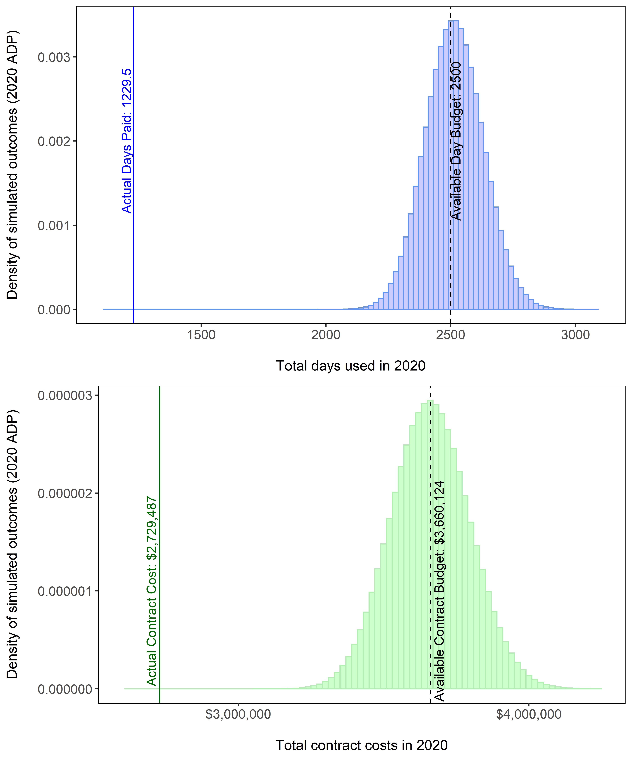

Figure 1. -- Total number of observer sea days purchased (top panel) and total cost of observing those sea days (bottom panel). Vertical bars signify the range of potential outcomes predicted by the 2020 Annual Deployment Plan. Dashed lines signify available budget. Solid lines signify what actually occurred in 2020.

##### 

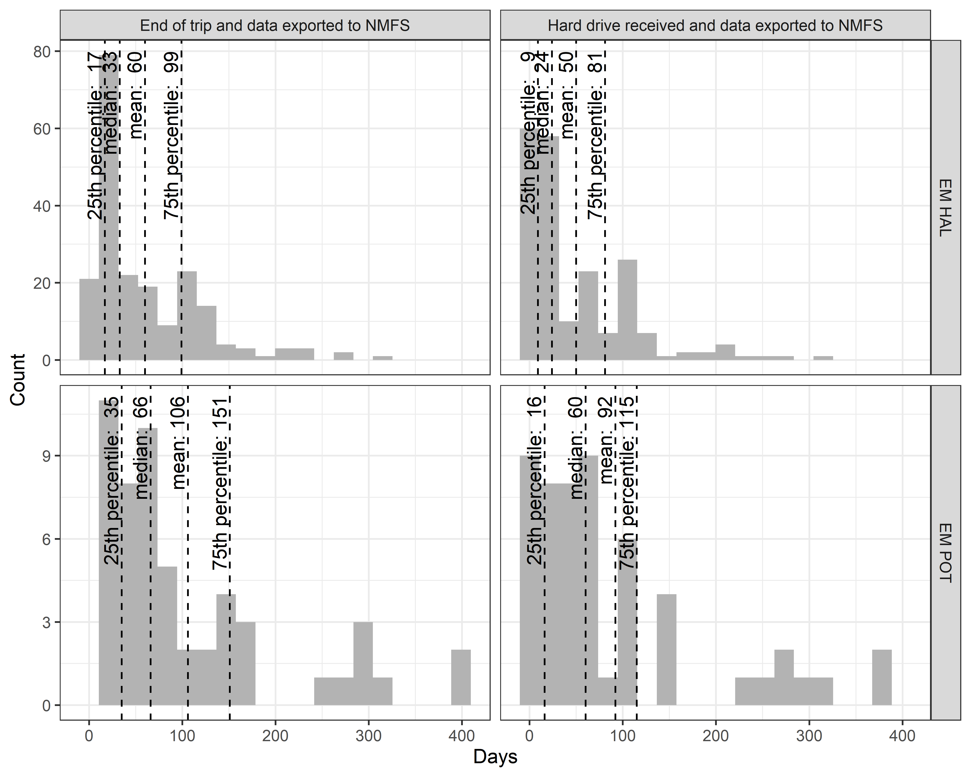

Figure 2. -- Histogram of days taken for fixed gear EM data review by stratum. Columns are not additive, and instead represent two different ways of measuring review time, starting from either the end of the trip or from the date at which the hard drive was received.

##### 

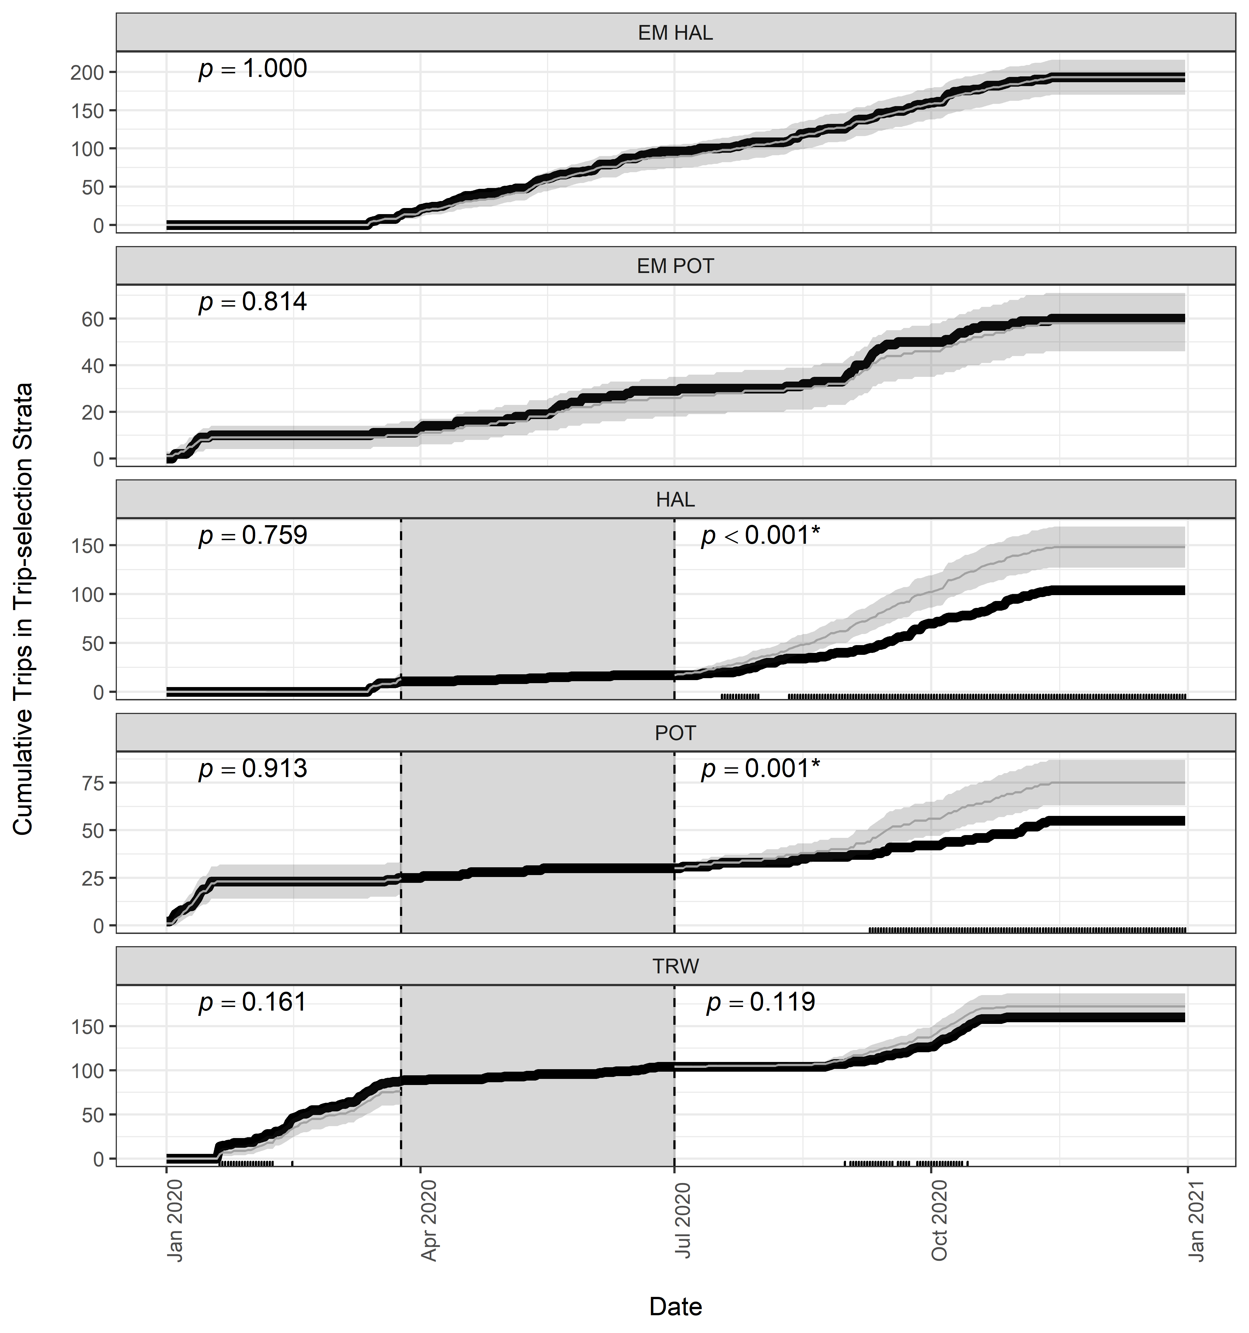

Figure 3. -- Cumulative number of trips monitored during 2020 (black line) compared to the expected range of observed trips (shaded ribbon) given fishing effort and sampling rates. Dates where the monitored number of trips is outside of expected (less or more than the range) are depicted as tick marks on the horizontal x-axis. The results of tests that the observed rate derived from a binomial distribution sampled at the selection rate are denoted as *p*-values. Dashed vertical lines and shaded rectangles denote the period when waivers were being issued for observer coverage due to COVID-19. During the waiver period, there was no expected number of observed trips. The EM strata were not affected by the waiver period, and so the expected numbers of monitored trips in those strata are uninterrupted.

##### 

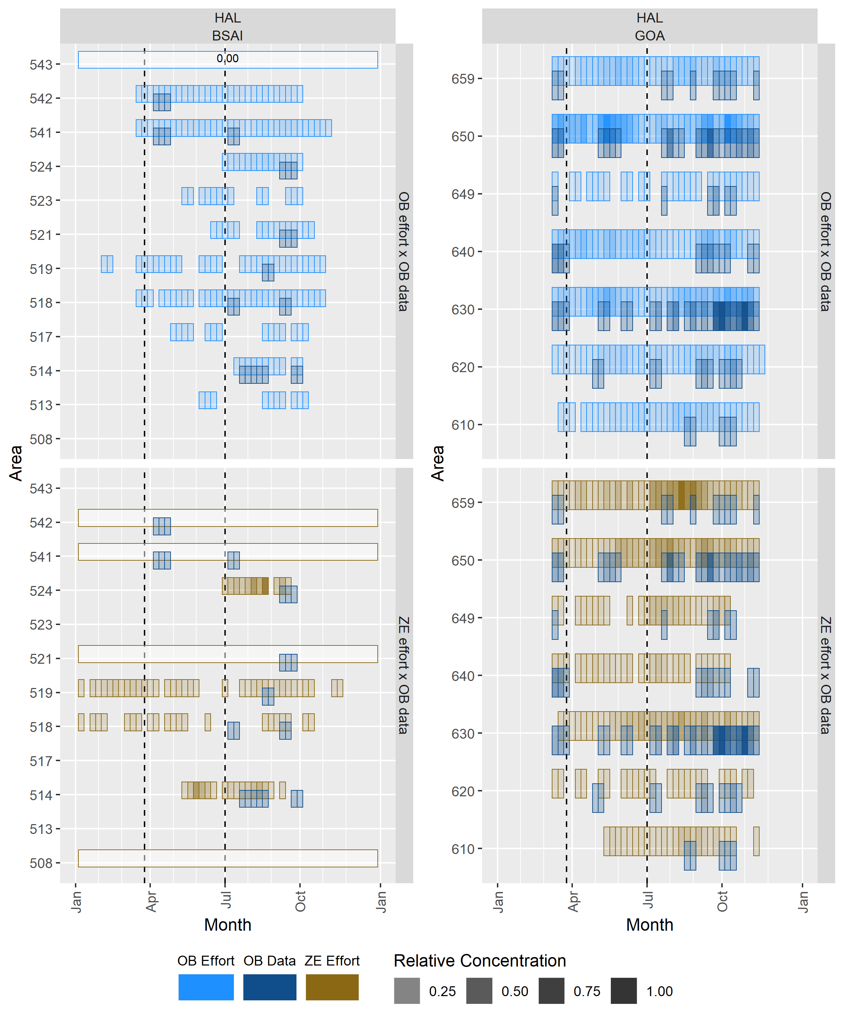

Figure 4. -- Relative concentrations of fishing effort and monitoring coverage for the observer (OB) *HAL* stratum (blue) and Zero Coverage (ZE) stratum trips that used hook-and-line gear (goldenrod) for each week of 2020. Areas with fewer than three distinct fishing vessels were obscured and replaced with proportions of trips that were monitored. Vertical dashed lines depict different time periods of 2020.

##### 

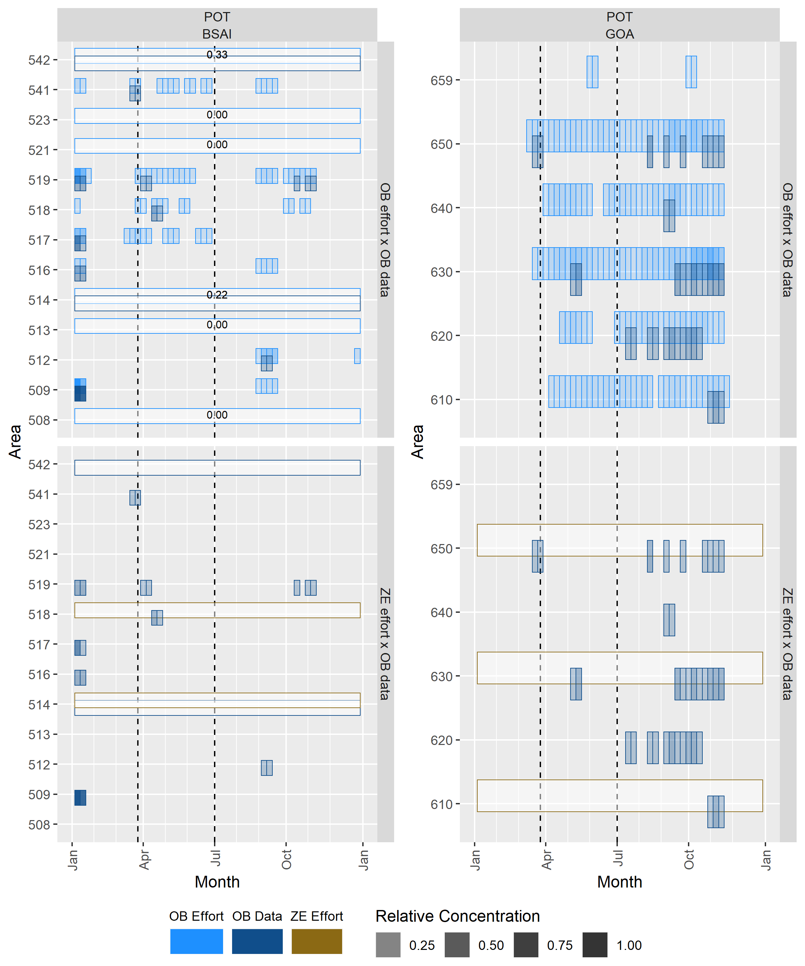

Figure 5. -- Relative concentrations of fishing effort and monitoring coverage for the observer (OB) *POT* stratum (blue) and Zero Coverage (ZE) stratum trips that used pot gear (goldenrodbrown) for each week of 2020. Areas with fewer than three distinct fishing vessels were obscured and replaced with proportions of trips that were monitored. Vertical dashed lines depict different time periods of 2020.

##### 

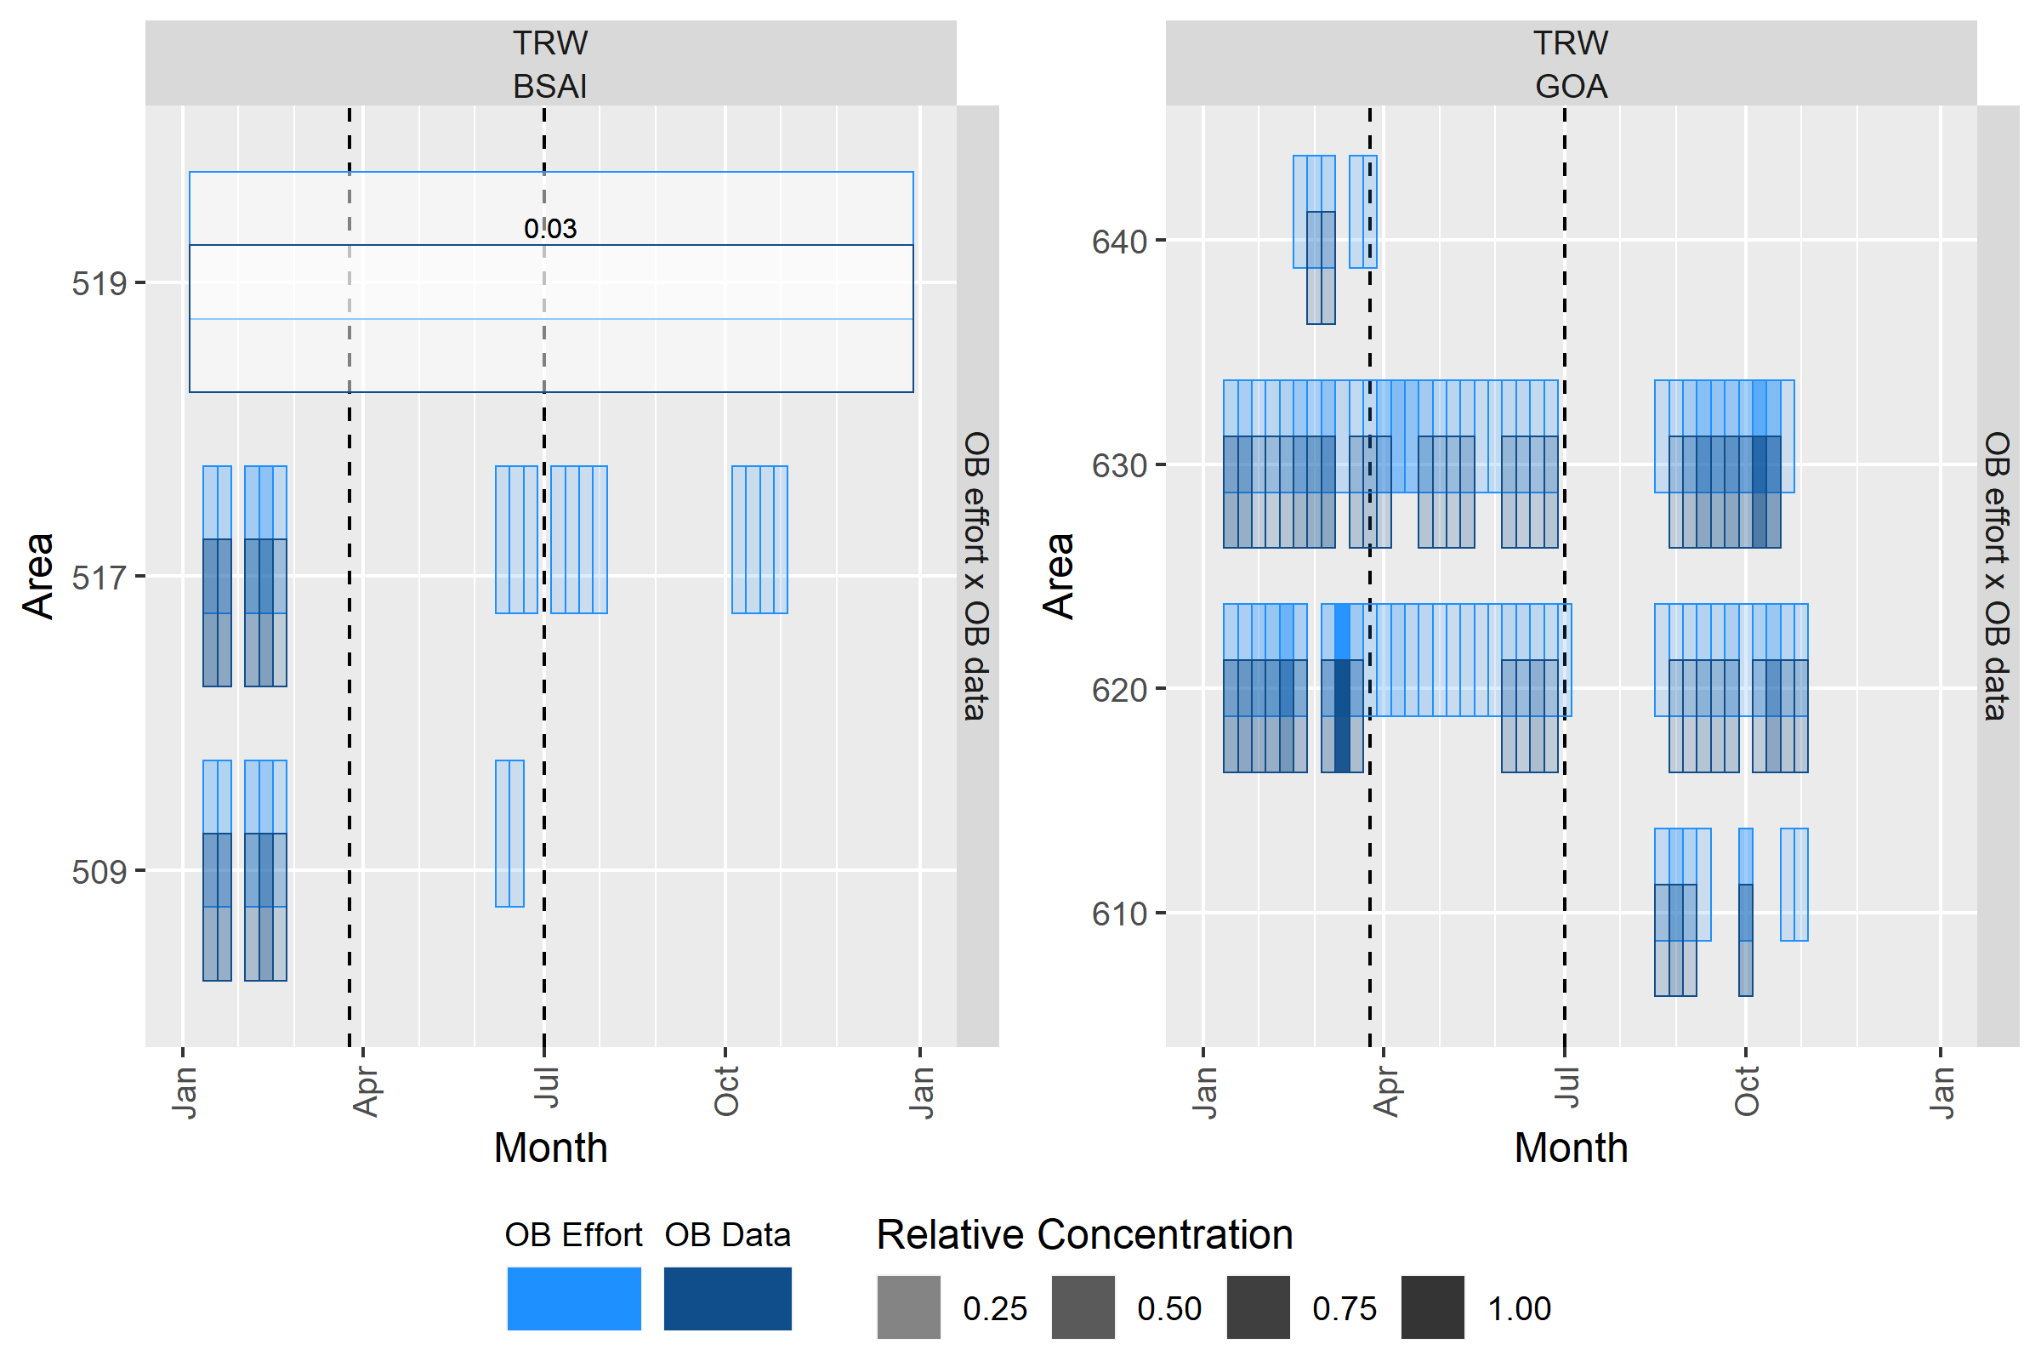

Figure 6. -- Relative concentrations of fishing effort and monitoring coverage for the observer (OB) *TRW* stratum for each week of 2020. Areas with fewer than three distinct fishing vessels were obscured and replaced with proportions of trips that were monitored. Vertical dashed lines depict different time periods of 2020.

##### 

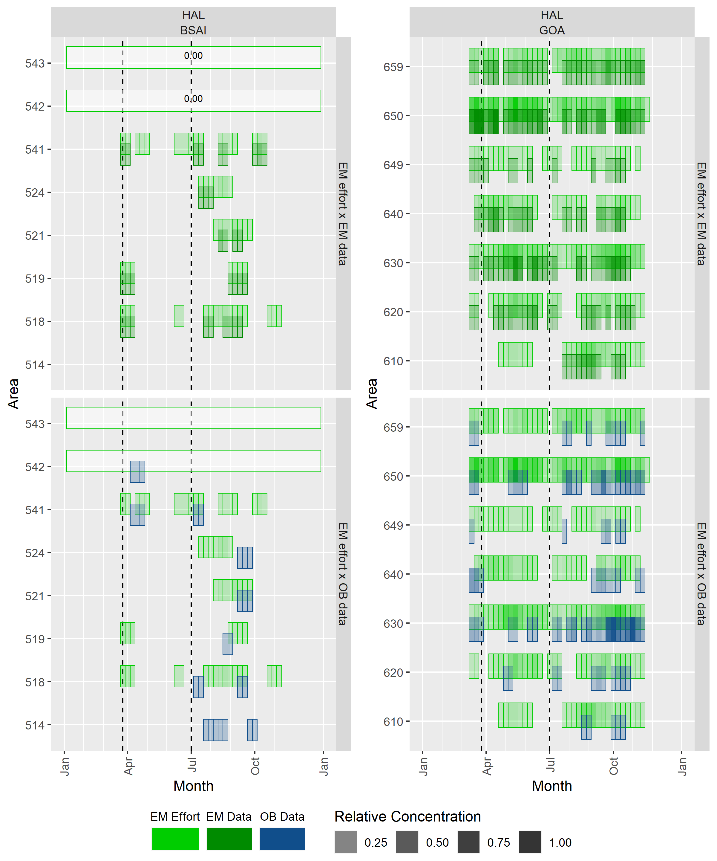

Figure 7. -- Relative concentrations of fishing effort and monitoring coverage for the *EM HAL* stratum (green) and observer (OB) *HAL* stratum (blue) for each week of 2020. Areas with fewer than three distinct fishing vessels were obscured and replaced with proportions of trips that were monitored. Vertical dashed lines depict different time periods of 2020.

##### 

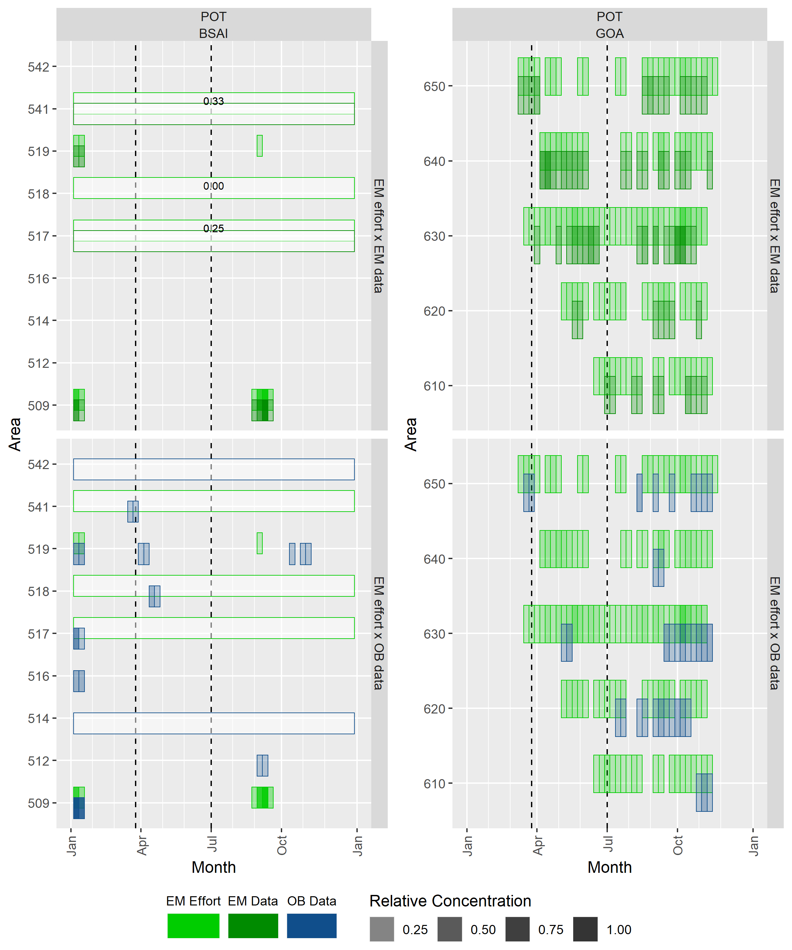

Figure 8. -- Relative concentrations of fishing effort and monitoring coverage for the *EM POT* stratum (green) and observer *POT* stratum (blue) for each week of 2020. Areas with fewer than three distinct fishing vessels were obscured and replaced with proportions of trips that were monitored. Vertical dashed lines depict different time periods of 2020.

##### 

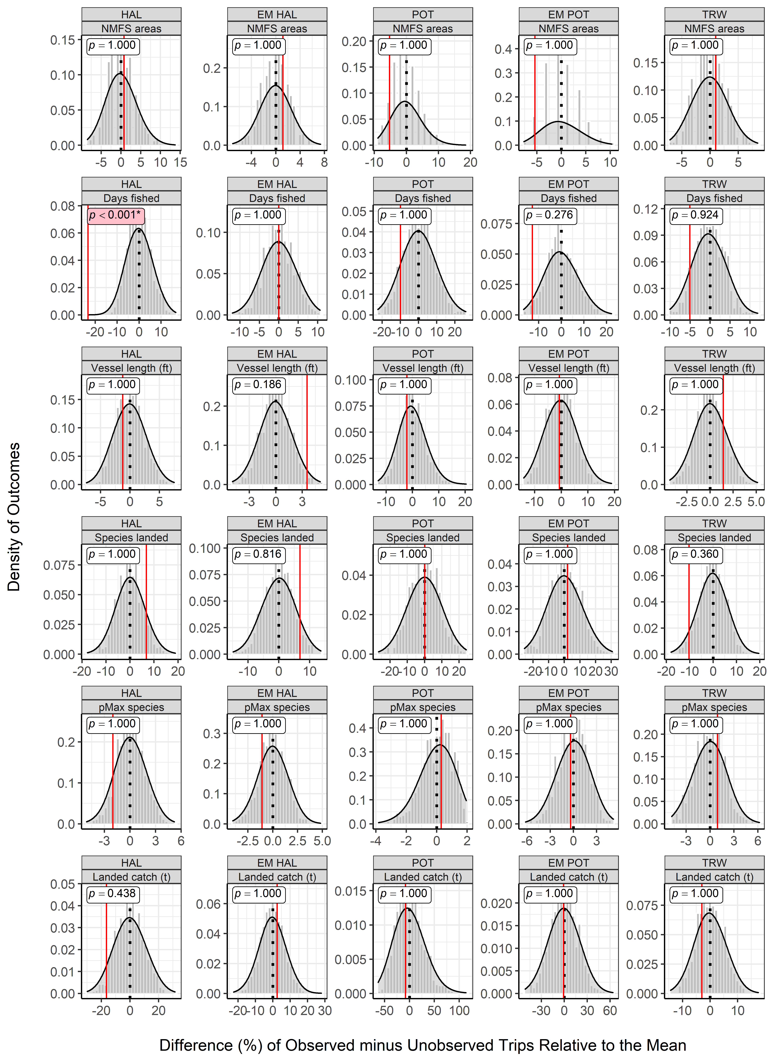

Figure 9. -- Results from permutationrandomization tests depicting percent differences between monitored and unmonitored trips by strata in the partial coverage category. Grey bars depict the distribution of differences between monitored and unmonitored trips when the assignment of monitoring status has been randomized (this represents the sampling distribution under the null hypothesis that monitored and unmonitored trips are the same). The vertical red solid line denotes the actual difference between monitored and unmonitored trips. Values on the x-axis have been scaled to reflect the relative (%) differences in each metric. The *p*-value for each test is denoted in the upper left corner. Low *p*-values are reason to reject the null hypothesis and conclude that there is a monitoring effect.

##### 

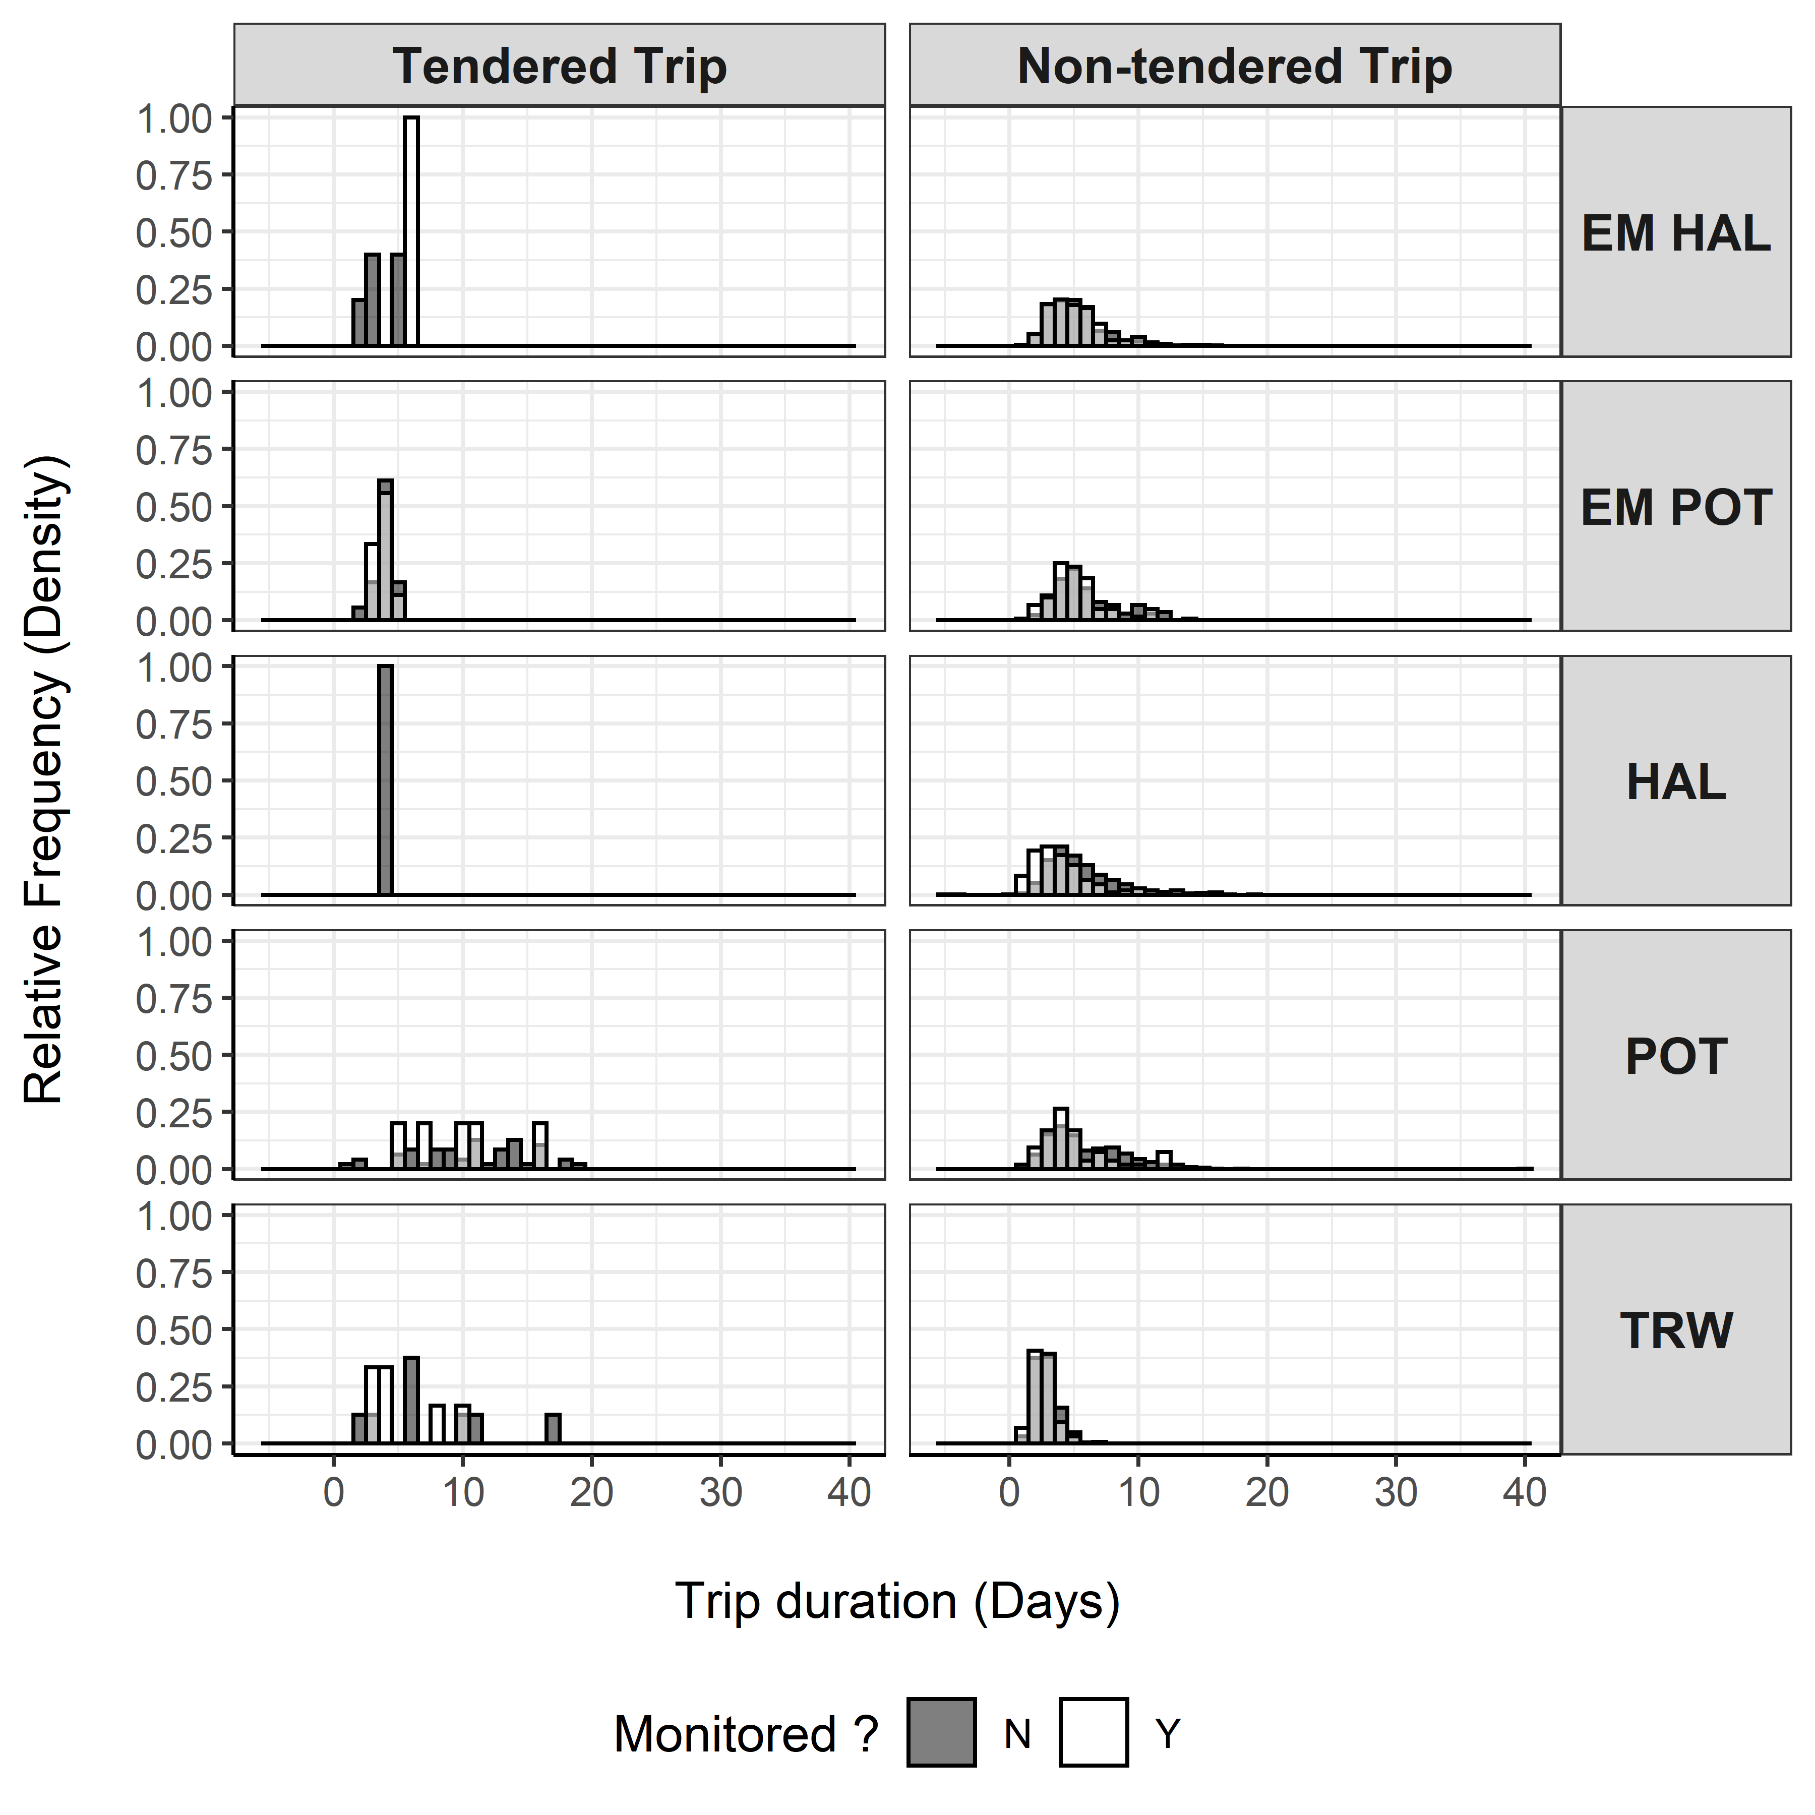

Figure 10. -- Distribution of trip durations for vessels in the partial coverage category by stratum and monitoring status. Monitored trips are depicted as transparent white bars overtop of solid black bars for unmonitored trips. Trip durations where both monitored and unmonitored status exist are depicted in gray (This is not the same as a stacked bar chart, in which the height of the bar would reflect monitored and unmonitored on top of one another, this plot has each monitoring status in front of the other).

##### 

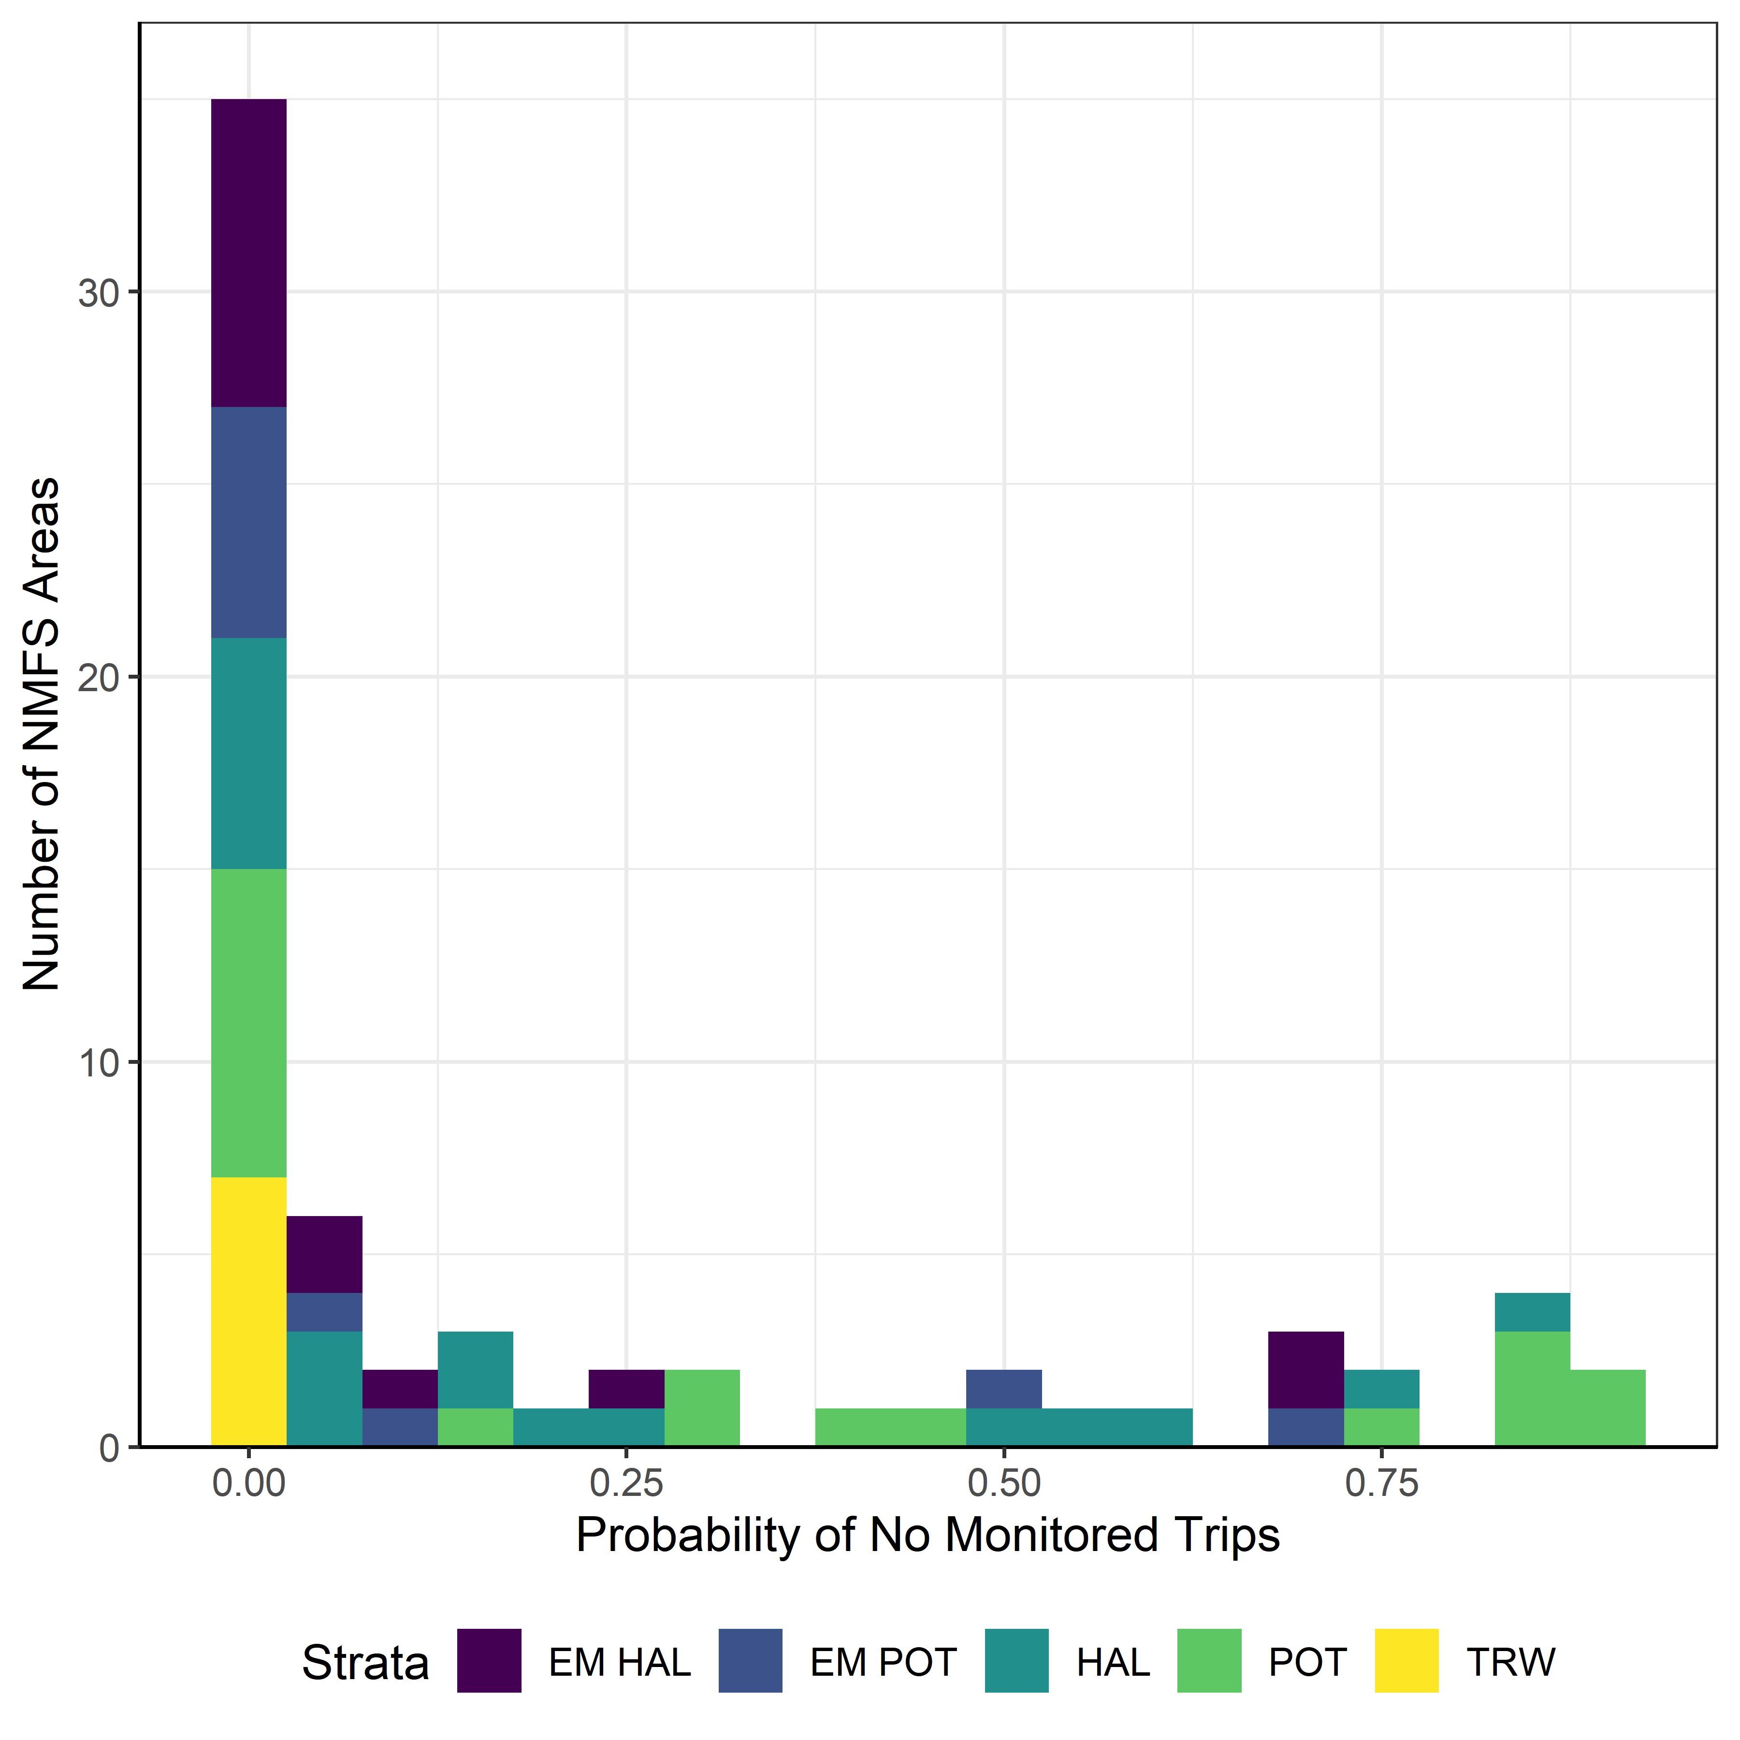

Figure 11. -- The number of NMFS Areas within each stratum that have a given probability of having no monitored trips in 2020.

1. While the revised 2020 deployment plan included 14 ports from which observers would be deployed, operationally the program was unable to deploy partial coverage observers from Akutan, as no lodging allowed for completion of a quarantine period in this port. Full coverage observers were deployed from Akutan without interruption.
2. Following methods in Ganz and Faunce (2019).